Philomena Kauffmann
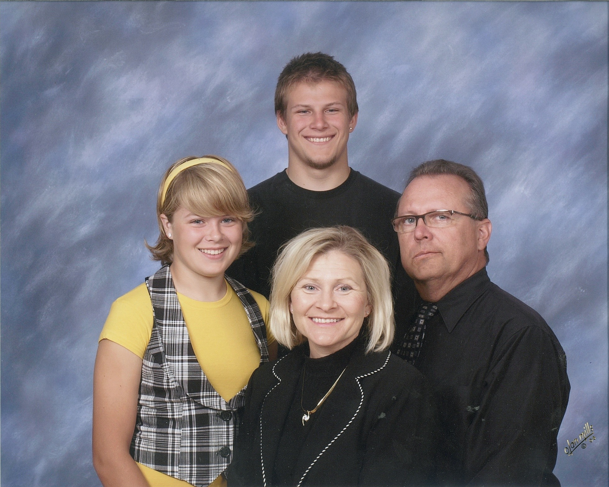
Administrative Assistant, Alumni Relations
Completed 28 years at Gustavus

Education:
Minnesota Lake High School
Mankato Vocational-Technical College
Completed 2 years Mankato State and Gustavus

Husband – Mark
Children – Mark,II (age 20), Megan (15)
and Benjamin (deceased)

Interests: Running, baking, scrapbooking, sports, reading and shopping.

