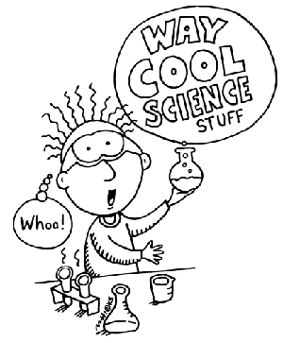
CHEM
6
C
Carbon
71
Lu
Lutetium
’
5
B
Boron
16
S
Sulfur
First Meeting!!!

Thursday Sept. 24th
9 pm in the Fish bowl

Where is the Fish bowl????
Go through the doors on the North side of Nobel and down the stairs,
then go through the first doorway on the right and follow the little hallway to the back corner.


Biochemistry and Chemistry majors will stay afterwards to answer any questions about majors, classes, etc.

