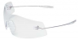

Contact Mandy Halfen (ahalfen@gac.edu)
by Friday October 15th.

