Monogamy versus Promiscuity in Voles

Document Overview:
Description of Lesson
Video Clips
Recommended Prior Knowledge for Students
Extensions
Classroom Handout for Research
Student Handout

Minnesota State Science Standards:
9.4.1.1.1 Explain how cell processes are influenced by internal and external factors, such as pH and temperature, and how cells and organisms respond to changes in their environment to maintain homeostasis.
9.4.3.3.4 Explain why genetic variation within a population is essential for evolution to occur.
9.4.3.3.6 Explain how genetic variation between two populations of a given species is due, in part, to different selective pressures acting independently on each population and how, over time, these differences can lead to the development of new species.

Objectives:
- Students will compare and contrast prairie voles with montane voles in terms of physical description, diet, habitat, mating behaviors, and rearing of young.
- Students will discuss possible causes for the differences in reproductive behaviors between prairie voles and montane voles.
- Students will discuss pros and cons of monogamy versus promiscuity in the two vole species.
- Students will analyze data involving the impact of hormones on brain function and behavior.
- Students will analyze the evolutionary connection between habitat and behavior difference amongst the two vole species.

Type of Activity: Research and Discussion

Duration: 1-2; 50-55 minutes

Connection to Nobel speakers:
Speaker: Larry J. Young, Ph.D. William P. Timmie Professor, Department of Psychiatry and Behavioral Sciences, Emory University School of Medicine, and collaboratory leader, Center for Behavioral Neuroscience, Atlanta, Ga.
  - Larry Young has spent his professional life trying to understand the relationship between genes, brain, and innate behaviors. As a postdoctoral fellow he began investigating the molecular mechanisms underlying social attachment in prairie voles, which differ from other species of voles in forming lifelong social bonds. Earlier research had identified two hormones in the regulation of pair bond formation in prairie voles and, using comparative molecular approaches, Young investigated the molecular mechanisms underlying the species’ differences in behavior. His lab is now using interdisciplinary approaches to understand how specific genes regulate the expression of innate behaviors, with a continuing focus on social attachment and social behavior in general. By understanding the mechanisms underlying social attachment, he and his colleagues hope to gain insight into human disorders characterized by social impairments, including autism spectrum disorders and schizophrenia.

Materials:

Computer/Internet Access and/or provided articles
Video Clips (internet)
Student Handout
Colored Pencils

Description of Lesson:
In this lesson, students will explore the vastly different reproductive strategies of two closely related species of voles: Prairie voles and Montane voles. The teacher may choose to provide an anticipatory set by discussing monogamy with students: What the term means, why it may or may not occur amongst human couples (divorce rate), pros and cons of monogamy in humans, etc. Students will begin by researching the two different species of voles using the provided handout. The teacher may choose to provide students with the provided in-class article to support the research or allow them to search on their own. Upon completion of the research, students will watch the video clip: “Why Do Voles Fall in Love?” as well as a series of video clips from Nobel Conference 2011 speaker, Larry Young, PhD. The teacher may choose to have students analyze and interpret the actual data provided in the article individually or in groups as some of the content is rather deep. “Vasopressin in the vole brain”, an fMRI picture, may be viewed as a class. (http://www.psy.fsu.edu/~wanglab/photos.htm) At a basic level, the teacher may ask students to identify where the pleasure center is in the vole brain, and how they know. Another option is to challenge students to determine, in their own words, what the data in the provided article conveys. Finally, the teacher may choose to have students complete the analysis questions individually, with a partner, in groups, or as a large-class discussion.

Note: The teacher may use this lesson with ecology, evolution, genetics, or body systems.

Video Clips:

- Why Do Voles Fall in Love? http://research.yerkes.emory.edu/Young/index.html
- Series of 8 video clips surrounding Larry Young and his research: http://www.dnalc.org/search?q=voles

Recommended Prior Knowledge for Students:
It would be helpful, but not required, for students to understand how neurons and hormones function.

Extensions:
- Supplementary Article about human hormones and pair-bonding: “Genetic variation in the vasopressin receptor 1a gene (AVPR1A) associates with pair-bonding behavior in humans”http://www.pnas.org/content/105/37/14153.full.pdf+html

- General info:“The annual vole meeting”. http://www.cbn-atl.org/research/voleconference.shtml

- Conservation: The prairie vole population is threatened by the increase of agriculture in the midwest. Voles can be viewed as pests or as essential to a habitat. They are apart of the natural food webs in their niche. Have students research whether voles are threatened or regarded as pests.
Importance of the vole:
http://people.uwec.edu/muehlesa/ENGL355PrairieVole.pdf
Voles in the landscape:
http://www.extension.umn.edu/distribution/horticulture/M1280.html
Northern Rockies Natural History Guide/ montane vole: http://nhguide.dbs.umt.edu/index.php?c=mammals&m=desc&id=19

- MN DNR-Voles: http://google.dnr.state.mn.us/search?q=voles&site=PublicSite

- Albert Einstein’s: Thinking about Thinking. Here’s your chance to be an ethologist (“animal behaviorist”). This is an inquiry activity that can be done as homework or an in-class assignment. Students observe a group of animals for an hour. They then analyze the behavior of the group and of the individuals and the relationships that occur. Are there benefits to group and individual behaviors? http://www.pbs.org/safarchive/4_class/44_guides/guide_903/4493_thinking.html

- Students may research other animals (especially mammals) that are monogomous.

- How the termite brain works. General information on the termite and how its brain functions. http://www.forteantimes.com/strangedays/science/382/hive_minds.html

- Termite Lab Activity. Termites work in a cooperative community to meet the needs of all individuals in a colony. This lab can be used to test how an animal’s behavior changes based on the pheromones in an ink pen. How does cooperative behavior assist in the survival of the colony? How do pheromones assist the colony? How do pheromones interact with neurons and the brain?
http://cas.bellarmine.edu/tietjen/Laboratories/Termite%20Trail%20Following%20Behavior.pdf
http://www.uky.edu/Ag/Entomology/ythfacts/resourc/tcherpln/termtrails.pdf

- Pill Bug Lab. This is an AP biology lab that can be modified to look at individual behavior as well as behavior of the bugs as a group. Students can use this lab to comment on how the behavior of the pill bug could be linked to behaviors of the voles. Do the bugs work as individuals or as a group? Can you measure pleasure? How is it measured in the pill bug? By eating the food? By moving away from chemicals?
http://www.biologycorner.com/worksheets/isopod_behavior_lab.html

- Darwin’s “The Descent of a Man” Chapter VIII. There is a section on the principles of sexual selection and polygamy in animals that can be used as a higher level reading. Students can identify animals and their sexual selection preferences.
http://www.darwin-literature.com/The_Descent_Of_Man/10.html

More Resources:
- Vole Photo Gallery: http://www.psy.fsu.edu/~wanglab/photos.htm
- Voles Facts for Kids: http://www.pestworldforkids.org/voles.html
- Article: Love is a chemical addiction http://www.oxytocin.org/oxytoc/love-science.html
- Vasopressin/oxytocin:http://www.brookscole.com/chemistry_d/templates/student_resources/0030244269_campbell/HotTopics/Love.html
- Love is a Virus: http://www.corante.com/loom/archives/2004_06.html

Classroom Handout for Research:
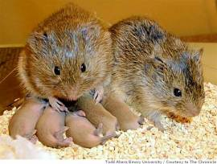
Monogamous Voles
Introduction:
If you watch prime-time television, or read celebrity gossip magazines, you might come to the conclusion that monogamy is an unnatural condition. And in many animals, in fact, it is: the male sticks around just long enough to mate with a female, and then leaves her to take care of the kids. But other animals are genetically programmed to settle down with a long-term partner. In this Science Update, you’ll hear about two different species of rodents, called voles, which have two very different strategies in this department. What sets them apart?

Transcript with Dr. Young:
A rodent's cheating heart.
Why is one male monogamous, while another plays the field? In humans, that's still difficult to answer. But in little mouse-like rodents called voles, scientists are getting a pretty good idea.
Larry Young is a researcher at Emory University and the center for behavioral neuroscience. He says one vole species, called the Montane vole, is promiscuous -- the male skips out on his mate as soon as she's pregnant. But his closely related cousin, the prairie vole, is monogamous.
Young: They form these long lasting social attachments with each other. And the males and females nest together, they have their babies, and the males spend just as much time taking care of those babies as the females do.
So why are they different? Young says a prairie vole gets a natural high from being with its mate, while the Montane vole doesn't.
Young: When a monogamous prairie vole mates, vasopressin is released and it activates receptors in certain areas of the brain that are involved in pleasure and reward. And they're actually the same areas of the brain that amphetamines and cocaine act on to produce addiction.
Young says understanding how such behaviors are controlled in simpler creatures could someday help us understand our own.
For the American Association for the Advancement of Science, I'm Bob Hirshon.

Figure 3 | Vasopressin V1a receptor and attachment in prairie vole male. a | Montane and prairie voles have different distributions of V1a receptor binding, with prairie voles having relatively high densities of receptors in the ventral pallidum (VP). (LS, lateral septum.) b | The species differences in receptor distribution are probably responsible for the species differences in the behavioural effects of arginine vasopressin (AVP) and perhaps in the formation of social attachments. In a test of nonspecific affiliative behaviour, intracerebroventricular AVP infusions increase social interest in the male prairie vole but not in the montane vole. Furthermore, AVP stimulates the formation of a partner preference in the absence of mating and V1a receptor antagonists prevent partner preference formation after extensive mating bouts. (CSF, cerebrospinal fluid.) c | These species differences in receptor distribution might be the result of species differences in gene structure. The prairie vole V1a receptor gene has been duplicated with one copy being downstream of a retrotransposon element (LINE) and it also has a frameshift mutation in the coding region. Both copies have a large complex repetitive expansion (red) just over 700 bp from the transcription start site. Either the gene duplication or the promoter expansion could contribute to the evolution of the expression pattern. (Figure modified with permission from Ref. 70 © (1999) Macmillan Magazines Ltd.)

Vasopressin in the Vole Brain
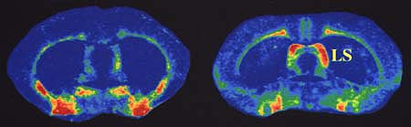
Prairie Vole Montane Vole

Making Sense of the Research:

Scientists have long been interested in the biological roots of mating behavior, since animals have so many different strategies and social norms. In this case, remember that we're not talking about apples and oranges: these are two different kinds of voles, with pretty subtle differences between them.
The difference Young is interested in has to do with the way the voles' brains respond to vasopressin. That's a brain hormone that helps male animals form social and, if you will, romantic attachments. The main difference between the monogamous prairie voles and the love 'em-and-leave 'em Montane voles isn't in how much vasopressin they have, but in the exact location of the cells that respond to vasopressin in the brain. In the prairie voles, they're concentrated in areas that produce feelings of pleasure and reward. So these are the kind of voles that might write mushy songs about how wonderful it feels to be in love, if in fact voles wrote songs. They more or less get "addicted" to mating with a particular female. For the Montane voles, on the other hand, the prospect of settling down just isn't so thrilling. That's because the cells that respond to vasopressin in their brains don't produce the same feelings of pleasure.
So in other words, it looks like something as simple as the distribution of a few very specific cells in the brain makes the difference between a playboy and a family guy. At least in voles. In humans, the picture is probably a lot more complicated. But humans have vasopressin too, and it's possible that individual differences in the way our brains react to it could help shape our attitudes toward marriage, monogamy, and commitment.

What is love? Neuroscientists can't answer that question yet. But they have learned more about how the feelings that occur when people “bond” are produced in the brain. If you look at how humans bond with their mates and care for their young, you'll see some surprising similarities between us and other species. Can family bonds be strengthened and weakened by chemicals in your brain?

Only about 5 percent of mammal species form exclusive, lifelong bonds with their mates. One is the prairie vole: Chemicals in a vole's brain make it link its mate with good feelings, and pairs tend to stay together for life. One of these chemicals is the neurotransmitter oxytocin. Prairie voles with more oxytocin receptors tend to stay with their mates. Voles with low levels mate with new partners.

Oxytocin plays a key role in the bonding process in voles—but what about in humans? In humans, as in prairie voles, oxytocin is released during birth, nursing, and mating—important bonding moments. Inhaling oxytocin in a nasal spray makes people feel more trusting in clinical studies. And in studies, men with naturally low oxytocin levels were less likely to get married.

So is oxytocin the secret of love? No. It is just one chemical messenger in the brain—a small part of a very complicated system. And it's not the only messenger involved in producing feelings of love and affection. Dopamine is a key messenger in the brain's “seeking system” that generates desire, and endorphin activates your pleasure centers when you find what you were looking for.

Student Handout:
PRAIRIE VOLES VERSUS MONTANE VOLES

Briefly describe the animals: Prairie Montane
- Physical Description(Size/Color):

- Diet:

- Habitat Description:

- Impact on habitat:

- Mating Behavior

- Rearing of young:

- Brainstorm what could be the cause of the difference in mating behaviors.

Color code the regions of each vole’s habitat. Use 2 different colors. Include a key.

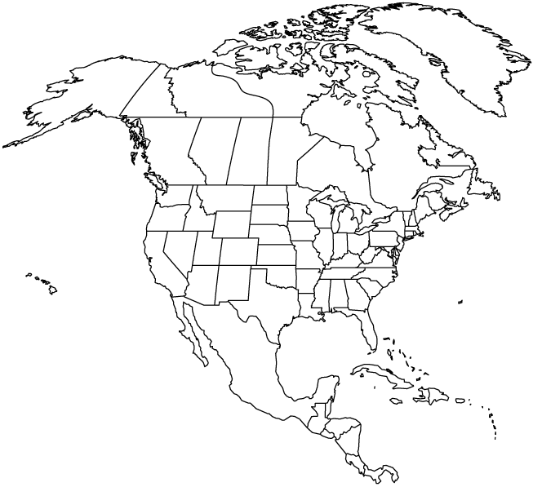

Analysis Questions/Discussion:
*To be completed after viewing video clips:
- Why Do Voles Fall In Love? http://research.yerkes.emory.edu/Young/index.html
  - Also available on youtube!
- Series of 8 video clips surrounding Larry Young and his research: http://www.dnalc.org/search?q=voles

How are monogamous prairie voles different from promiscuous Montane voles?

Suppose you put a male prairie vole in a cage with a female, allowed them to mate, but injected the male with a drug that blocked the activity of the vasopressin hormone. What do you think would happen? (Scientists have actually done this experiment.)

What if you gave a male Montane vole an extra injection of vasopressin before mating? Would he form an attachment to the female? Why or why not?

In the animal world, what are some of the advantages of monogamy? What are the drawbacks? What do animals gain by avoiding long-term attachments?

Some scientists think an animal's environment can influence the type of mating strategy it uses. The monogamous prairie voles live in open, flat grasslands. The promiscuous Montane voles live in the Rocky Mountains. How do you think their mating strategies fit into their environments? (Remember that voles are small and easy targets for predators).

If humans could be given a drug, or some kind of medical treatment, that made them more able to commit to their mates, would you approve of it? What if it made them more social and loving in general?

