Neuroethics

Document Overview:
Activity 1-Introduction to fMRI’s and Neuroehics
Activity 2-Brain Enhancing Drugs
Activity 3-Are fMRI’S Reliable?
Additional Resource List
Student Handout-Brain Finger Printing Images
Student Handout-Introduction to fMRI
Student Handout-Neuroethics the practical and philosophical
Student Handout-Activity 2-Pills That Keep Your Mind Afloat
Student Handout-Activity 3-Are fMRI’s Reliable

Minnesota State Science Standards:
9.1.1.1.4 Explain how societal and scientific ethics impact research practices.
9.1.1.1.5 Identify sources of bias and explain how bias might influence the direction of research and the interpretation of data.
9.1.2.1.1 Understand that engineering designs and products are often continually checked and critiqued for alternatives, risks, costs and benefits, so that subsequent designs are refined and improved.
9.1.2.1.2 Recognize that risk analysis is used to determine the potential positive and negative consequences of using a new technology of design, including the evaluation of causes and effects of failures.
9.1.3.3.1 Describe how values and constraints affect science and engineering.
9.1.3.4.4 Relate the reliability of data to consistency of results, identify sources of error, and suggest ways to improve data collection and analysis.
Objectives:
Upon completion of this lesson, students will be able to:

a. Identify the basic parts of the brain and explain their main functions.
b. Describe the difference between MRI and fMRI.
c. Differentiate between normal and abnormal fMRI.
d. Explain and understand in general terms what Neuroethics is.
e. Look at brain fingerprinting scans and differentiate between normal and abnormal scans.
f. Understand that ethical questions may arise with advances in technology.

Type of Activity: Research, role play, debate, class discussion
Duration: Activity 1: One 45 minute class period
Activity 2: Two 45 minute class periods
Activity 3: Three to four 45 minute class periods

Connection to Nobel speakers:

Martha J. Farah, Walter H. Annenberg Professor in Natural Sciences and Director, Center for Neuroscience and Society, University of Pennsylvania, Philadelphia
  - A prominent neuroscientist and one of the founders of the field of neuroethics, Martha Farah is uniquely qualified to discuss the impact of neuroscience applications and advances upon individuals and humanity in general and the place of neuroscience in society.

Teacher Tips: For successful completion of this lesson we recommend the following:

1. Reviewing the “Brain Basics” lesson plans. (Included with Nobel Conference Curriculum)
2. Review fMRI tutorial. (Included with Nobel Conference Curriculum)
3. You may want to make color copies of the the scans or use a projector or show them since they are better to observe in color.
4. You may want to make copies of several of the “additional sources” to create a library of current articles that are at different levels for students to read for additional information.
Concepts, Connections, and Terms
  - Neuroethics
  - fMRI
  - MRI
  - Brain finger printing
  - Cognitive

Materials:
1. fMRI Scans: Normal and Abnormal (Included in Activity 1)
2. Access to computers
3. Student handouts
4. Brain fingerprinting scans, Normal and Abnormal (Included in Activity 1)

Activity 1 -Introduction to fMRI and Neuroethics
• Read - Introduction to fMRI
http://www.fmrib.ox.ac.uk/education/fmri/introduction-to-fmri/contents
• Read - “Neuroethics: The Practical and the Philosophical” (you may want to interchange or substitute this with the You-Tube video or the Nobel Conference Lecture depending on the reading ability of your students)
www.psych.upenn.edu/~mfarah/Neuroethics-Practical.pdf

• Watch You Tube Videos of Martha Farah Part 1 and 2 (these may be a little quiet)
http://www.youtube.com/watch?v=X3OFGdrBz6k&feature=related
http://www.youtube.com/watch?v=TJ2ODgiKnKk&feature=related

• Hand out fMRI scans and have the students make observations of normal and abnormal scans.

• Students may use study guides while reading or to facilitate discussions.

• Assesement - Student participation and understanding of normal and abnormal fMRI. Completion of study guides.

Activity 2- Brain Enhancing Drugs
Read - “Pills That Keep Your Mind Afloat: What is the downside of brain-enhancing drugs?”
http://www.independent.co.uk/news/science/pills-that-keep-your-mind-afloat-what-is-the-downside-of-brainenhancing-drugs-2268008.html

Divide students into groups of 2 or 3 and give each group a copy of the ‘Student Questions’ for Activity 2. Have students discuss questions among themselves. After students have time for small group discussion, come together as a class and discuss and compare answers.

Assessment: Student participation and completion of handout.

Extension: Have students research “brain enhancing” drugs that have been used throughout history and what impact these enhancers may have had on society, specifically socially and economically. One example that you may want to explore is the use of Methemphetamines on Japanese pilots in WWII.

Activity 3-Are fMRIs Reliable Evidence?
Simulated Court Case - A student is suspected of stealing all of the cookie dough from the cafeteria causing a cookie shortage for the remainder of the school year. There is no physical evidence to link the suspect to the theft. There is only one eyewitness who is severely near- sighted and did not have her glasses on that morning. The court has decided to use fMRIs to help determine innocence of the suspect. The prosecutors do not want fMRIs used because they do not feel that the tests are reliable. The defenders want to use fMRIs because they believe it will prove their clients innocence. The jury will have to listen to both sides and make a decision on whether or not to allow fMRIs in the case.

Instructions:
• Divide the class into small groups. (Four to a group)
• Have two people in the group act in favor of the use of fMRI’s, they will be acting prosecuters in the case. Have two people act against the use of fMRI’s as evidence, they will be acting as the defenders in the case.
• The students that are in favor of using fMRI’s will need to research why fMRI’s should be used as evidence and record their findings on the data sheet enclosed.
• The students that are not in favor of using fMRI’s will need to research why fMRI’s should not be used as evidence and record their findings on the data sheet enclosed.
• Students should use at least 3 resources.
• After students have completed their research, they should have a “discussion” among their small group, trying to make their “case” . Prosecutors should make their case to the defenders and defenders to prosecutors. Each side should take notes on the information that the opposite group is presenting.
• At the conclusion of the small group discussion, hold a class discussion or debate on the findings.
• At the conclusion of the discussion have students fill out the remainder of the handout.
• At conclusion of “trial” you may want to show the video: www.youtube.com/watch?v= REqfGFKxBzU This is about “Brain Fingerprinting” and its use in the legal system.
• Assessment: student participation and group information/research that is handed in.

Additional Resources:
http://www.popularmechanics.com/science/health/nueroscience/4226614
http://www.forensic-evidence.com/site/Behv_Evid/Farwell_sum6_00.html
http://www.rense.com/general34/newbrainfingerprinting.htm
http://www.cognitiveliberty.org/neuro/harrington_amicus.html
http://www.truth-justice.org/Services%20-%20Brain%20Fingerprinting.htm

Student Handouts
Brain Scan Images
“Normal Brain Finger Printing Scan”
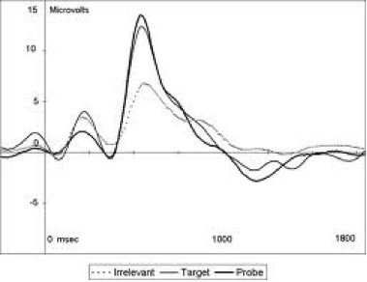

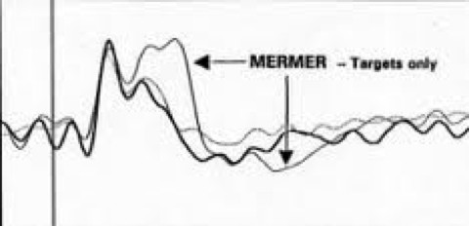
Mermer shows that the subject may be lying.

This fMRI image shows average brain regions for 22 subjects during testing. Blue areas represent brain regions more active when telling the truth, red areas, when lying.
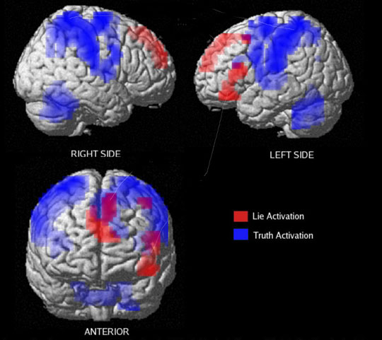
Image Courtesy Dr. Daniel Langleben

This article from NPR provides the above image: “Neuroscientist Uses Brain Scan to See Lies Form”

Images from http://www.npr.org/templates/story/story.php?storyId=15744871

Introduction to fMRI’s Study Guide

1. Who performed the first experiment that proved increased brain activity will increase blood flow to the brain?

2. When were fMRIs developed?

3. What are the three advantages of using fMRIs?

4. In MRIs, what is the signal that is detected?

5. What are MRIs of the brain able to discriminate between?

6. What does BOLD mean?

7. Blood oxygenation in the brain varies because of what activity?

8. What is a voxel? (you will need to look this up, it is not in the reading)
9. What are the three main groups of people that work at an fMRI laboratory? Briefly explain what each group does.

10. How are fMRIs used in clinical and commercial use?

Study Guide
“Neuroethics: The Practical and the Philosophical”

1. What are the neuroscience technologies that are presenting new ethical challenges?

2. Why would people use neuromarketing? What does neuromarketing measure?

3. What could “braintyping” be used for?

4. Is brain imaging a good measure of personality? Why or why not?

5. What is the important problem that arises with brain imaging?

6. What are the three ethical issues of brain enhancement?

7. What is the problem of neuroscience’s account of behavior?

After completing the reading, “What do you think?”
Do you think that people can be excused of certain behaviors because of how their brain may be wired? Should the be punishments for crimes be determined by how or what a persons brain reflects in neuroscience testing? Is a person really responsible for his/her actions?

Student Handout: Activity 2
Pills that keep your mind afloat: What is the downside of brain-enhancing drugs?

Discussion Questions:
1. You are trying to get into college. You know that you will qualify for a full paid scholarship if you can bring your grades up and score well on the ACT. Would you take a brain-enhancing drug to help you focus to improve your scores?

How long would you take the drug?

Are there any consequences that you are concerned with?

If a person takes brain-enhancing drugs are they cheating? Is this different from taking steroids to boost athletic ability?

After reading the article do you feel that there are any times when people should take brain-enhancing drugs? Is there justification for taking these drugs?

Is there any difference between people who rely on caffeine to function verses people who rely on brain-enhancing pills?

Student Handout for Activtiy 3
Activity 3- Are fMRI’s Reliable Evidence?
Simulated Court Case - A student is suspected of stealing all of the cookie dough from the cafeteria causing a cookie shortage for the remainder of the school year. There is no physical evidence to link the suspect to the theft. There is only one eyewitness who is severely near- sighted and did not have her glasses on that morning. The court has decided to use fMRIs to help determine innocence of the suspect. The prosecutors do not want fMRIs used because they do not feel that the tests are reliable. The defenders want to use fMRIs because they believe it will prove their clients innocence. The jury will have to listen to both sides and make a decision on whether or not to allow fMRIs in the case.

Are fMRI’s reliable evidence?
Your opinion (and why):

Prosecutor’s Side: We should use fMRI’s as reliable evidence. | Defender’s Side: We should not use fMRI’s as reliable evidence.

Your opinion (and why) after the prosecutor’s and defender’s have presented:

Did your opinion change as a result of the presentations? Why or why not? What evidence changed or did not change your opinion?

What ethical considerations did you make when considering the decision?

