Understanding the “Uncs”!

Document Overview:
Teacher Lesson Plan
Teacher Preparatory Work
Assessment
IB Rubric: Design
IB Rubric: Conclusion and Evaluation
Caenorhabditis elegans: An Introduction
Student pre-lab worksheet
Student lab handout

Minnesota State Science Standards:
9.4.1.1.2 Describe how the functions of individual organ systems are integrated to maintain homeostasis in an organism.
9.4.3.2.3 Explain how mutations like deletions, insertions, rearrangements or substitutions of DNA segments in gametes may have no effect, may harm, or rarely may be beneficial, and can result in genetic variation within a species.
9.4.4.1.1 describe the social, economic and ecological risks and benefits of biotechnology in agriculture and medicine.

Objective:
The student will be able to conduct an experiment that tests what effect a single point mutation (which causes a break in the synapse of neuron) has on the movement of C.elegans.

Type of Activity: Lab

Duration: Two 55-minute periods or an 80-minute period

Connection to Nobel speakers:
Larry J. Young, William P. Timmie Professor, Department of Psychiatry and Behavioral Sciences, Emory University School of Medicine, and collaboratory leader, Center for Behavioral Neuroscience, Atlanta, Ga.
  - Larry Young researches the social bonding of voles and the neurons that influence the bonding. Young says, “The real progress is understanding the relationships between genes, social experiences, neurological chemicals, and behavior will be made when we translate the vole work into primate studies.” This lab allows students to look at how the behavior of the C.elegans is affected when different neurons are absent or present. The study of neurons in the worms can be applied to human neurons and synapses.

Acknowledgements:
Modified from Brain U at http://brainu.org/c-elegans-and-alcohol
©2000-2011 BrainU, University of Minnesota Department of Neuroscience in collaboration with the National Center for Research Resources, a part of the National Institutes of Health.

Description of Activity: The student will experiment with a 3 varieties of C.elegans to examine how movement is affected. C.elegans wild type, C.elegans mild unc and C.elegans strong unc will be used in this experiment. The wild type will move through the media and create trails that students can observe. The mild unc has moderate movement. The strong unc is a mutated version of the wild type whose movement is restricted. A single gene has been altered (single point mutation) to make the strong unc immobile. The gene that has been altered closes the pathway in the nervous system that causes movement. Students will be able to measure the movement of the different C.elegans and formulate an explanation about why the organisms move differently.

Recommended Prior Student Knowledge:
- Neurons and synapses
- Effect of mutations on organisms
- Basic genetic understanding of DNA sequences, mutations

Concepts, Connections, and Terms
- Neurons
- Synapse
- Gene
- DNA sequences
- Mutation
- Single Point Mutation (if linking the lab into genetics)

Materials:
- Three varieties of C.elegans
- C.elegans: N2 (wild type) (lots of movement), mild unc (moderate movement), strong unc (does not move) See teacher preparatory section for information on how to order and strains
- Three small agar plates with E.Coli (worm food) per group
- Dissecting microscope
- Sharpie for labeling plates
- Pipette
- Eppendorf tube
- Ice
- Distilled water
- Video of C.elegans
  - Worm crawling: http://www.bio.unc.edu/faculty/goldstein/lab/crawl.mov
  - Other Videos Options:
    - C.elegans videos: http://www.bio.unc.edu/faculty/goldstein/lab/movies.html
    - Worm patterns: http://www.youtube.com/watch?v=7WOxyVvMp8s&NR=1
    - http://wn.com/Worm_Patterns (worm patterns)
    - Worm patterns: http://www.youtube.com/watch?v=kyl4Nt4Tzxk
    - Unc Mutation movement: http://www.youtube.com/watch?v=O8QnCeOTBqA&feature=related

  - Print out of:
  - Introduction to C.elegans (also located in this document): http://brainu.org/files/is_celegans.pdf
  - Concentrating the worms (also located in this document in the student procedures): http://brainu.org/files/overhead_concentratingtheworms.pdf
  - Laboratory sheet

Teacher Lesson Plan
- Day 1: Teacher or student groups need to pour agar plates and put E.coli on each plate the day before the lab. Each student group needs 3 plates. They should be labeled as C.elegans wild type, C.elegans mild unc and C.elegans strong unc.
- Day 1: Students should complete pre-lab before entering the lab and read the lab ahead of time. This can be sent home or can be done in class. Students will need the pre-lab student handout, the Introduction to C.elegans located in this document to complete the pre-lab or online at: http://brainu.org/files/is_celegans.pdf
- Day 1: The teacher should go over the lab the day before. The following videos can be shown the day before and the day of so students can quickly identify the worms on their plate.
  - http://www.bio.unc.edu/faculty/goldstein/lab/crawl.mov (Worm moving)
  - http://wn.com/Worm_Patterns (worm patterns)
- Day 2: Complete Day 1 directions in the student handout. Students should work in groups. Depending on how many plates of C.elegans you start off with: each group can concentrate one type of the C.elegans and share with other groups (make sure to have 2 plates of each C.elegans to concentrate in case a group makes a mistake). Info on how to concentrate the worms is located in this document in the student handout or can be viewed at: http://brainu.org/files/overhead_concentratingtheworms.pdf
- Day 2 or Day 3 (dependent on the length of the class): Complete Day 2 directions in the student handout. Students should follow the lab procedures in the document, take data and answer questions in the conclusion.

Teacher Preparatory Work:
- Order C.elegans
  - Carolina Biological Supply Company (http://www.carolina.com/) culture kit is item: 173525P comes with supplies for culturing worms, wild-type C. elegans, and two mutants.
  - The mutants described in the lesson plans would need to be purchased from the CGC (Caenorhabditis Genetics Center): http://www.cbs.umn.edu/CGC/
    - 1) N2 (the wild-type or normal animal)
    - 2) unc-51 (e369) (strong paralyzed animal). it also has a strain number CB369
    - 3) unc-42 (e270) is the weak unc. CB270
  - Prepare 3 agar plates with E.Coli (worm food) for each student group the day before (can also have students do this)
  - Each student group will need a stereoscope for viewing C.elegans structure and movement.

Assessment:
- A completed lab report including the answers to the summary questions.
- Can be assessed using the IB criterion: design and planning (D) and conclusions and evaluation (CE)

Extension Activity:
“C.elegans and Alcohol Experiment” located on the Nobel Conference 2011-2012 Teacher activities
IB Student Rubric
Student Name Class Hour Date
Design (D)
Levels/Marks | Aspect 1 | Aspect 2 | Aspect 3
 | Defining the problem & selecting variables | Controlling variables | Developing a method for collection of data
Complete/2 | Formulates a focused problem/research question and identifies the relevant variables. | Designs a method for the effective control of the variables. | Develops a method that allows for the collection of sufficient relevant data.
Partial/1 | Formulates a problem/research question that is incomplete or identifies only some relevant variables. | Designs a method that makes some attempt to control the variables. | Develops a method that allows for the collection of insufficient relevant data.
Not at all/0 | Does not identify a problem/research question and does not identify any relevant variables. | Designs a method that does not control the variables. | Develops a method that does not allow for any relevant data to be collected.
Comments:

Conclusion and Evaluation (CE)
Levels/Marks | Aspect 1 | Aspect 2 | Aspect 3
 | Concluding | Evaluating procedure(s) | Improving the investigation
Complete/2 | States a conclusion with justification, based on a reasonable interpretation of the data. | Evaluates weaknesses and limitations. | Suggests realistic improvements in respect of identified weaknesses and limitations.
Partial/1 | States a conclusion based on a reasonable interpretation of the data. | Identifies some weaknesses and limitations, but the evaluation is weak or missing. | Suggests only superficial improvements.
Not at all/0 | States no conclusion or the conclusion is based on an unreasonable interpretation of the data. | Identifies irrelevant weaknesses and limitations. | Suggests unrealistic improvements.
Comments:

Caenorhabditis elegans: An Introduction

What is Caenorhabditis elegans and why work on it?

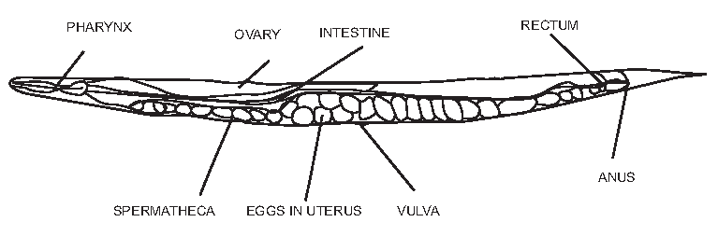
http://herkules.oulu.fi/isbn9514267567/html/graphic33.png

What is C. elegans?

C. elegans is a nematode – a member of the phylum Nematoda: The roundworms and threadworms, a phylum of smooth-skinned, unsegmented worms with a long cylindrical body shape tapered at the ends; includes free-living and parasitic forms both aquatic and terrestrial. (Academic Press Dictionary of Science and Technology)

It is small, growing to about 1mm in length, and lives in the soil – especially rotting vegetation –in many parts of the world where it survives by feeding on microbes such as bacteria.

A brief description of C. elegans
C. elegans is a free-living nematode. There are two sexes: a self-fertilizing hermaphrodite and a male. The adult essentially comprises a tube, the exterior cuticle, containing two smaller tubes, the pharynx and the gut, and the reproductive system. Most of the volume of the animal is taken up by the reproductive system.

Of the 959 somatic cells of the hermaphrodite some 300 are neurons. Neural structures include a battery of sense organs in the head which mediate responses to taste, smell, temperature, and touch – and although C. elegans has no eyes, it might respond slightly to light. Among other neural structures is an anterior nerve ring with a ventral nerve cord running back down the body. (There is also a smaller dorsal nerve cord.) There are 81 muscle cells. C. elegans moves by means of four longitudinal bands of muscle paired sub-dorsally and sub-ventrally. Alternative flexing and relaxation generates dorsal-ventral waves along the body, propelling the animal along. The development and function of this diploid organism is encoded by an estimated 17,800 distinct genes.
Adapted from: http://brainu.org/files/is_celegans_1.pdf
Name Class Hour Date

Understanding the “Uncs”!

Pre-Lab
Vocabulary. Draw or write.
Brain
Neuron
Axon
Dendrite
Synapse
Mutation
Mutant
Gene
Single point mutation
Protein
Unc

How do we move? Explain how you finger muscle moves. Write at least five steps. Use at least four vocabulary words from the list above in your description.

What is C.elegans? What phylum is it in?

What is the habitat of C.elegans?

Below is a diagram of the nervous system. Use the information in Figure 4 description to label the function of each of the nerves on the diagram.

Figure 4. Organization of mechano- sensory neurons in C. elegans. ALMs and PLMs are the major sensory neurons controlling sensation of soft touch in the anterior and posterior half of the animal. Anterior and posterior touch causes animals moving forwards and backwards, respectively, to reverse direction. The ALM and PLM processes are filled with large diameter microtubules which are required for mechanosensation. These neurons for both electrical and chemical synapses onto the command interneurons which control locomotion.

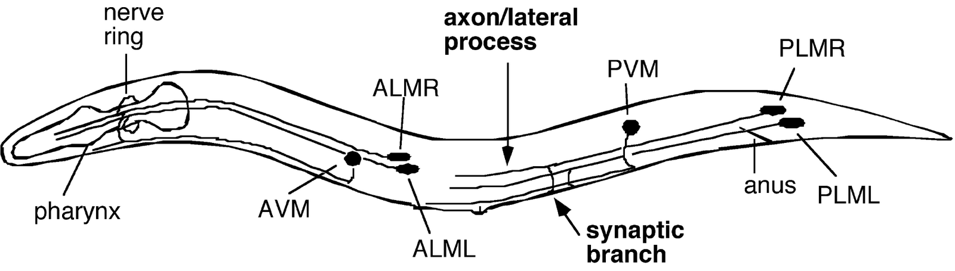

http://neuroscience.wustl.edu/nonetlab/ResearchF/elegans.html

How many neurons does C.elegans have?

What is most of the body of C.elegans made up of?

How does it move? Be specific.

Why are we using C.elegans to study movement and neurons? (Your opinion)

Name Class Hour Date

Understanding the Unc’s

Purpose: Evaluate how the motor neurons are important in the movement of C.elegans.

Hypothesis:

Procedure:
- Obtain a plate of C.elegans wild type, C.elegans mild unc, or C.elegans strong unc. Each group will be concentrating a variety of C.elegans to share with the other groups.
- Observe how the worms move around on the plate using a dissecting microscope
- Gently squeeze water into the plate of worms and swirl gently to get the worms into the water.
- Gently tip the worm plate slightly and suck up the worms and water into the pipette.
- Gently squeeze the water and worms into the Eppendorf tube.
- Cap the Eppendorf tube.
- Place the Eppendorf tube on ice. (Why put the worms on ice? What happens when small animals get cold? They slow down and try to conserve energy. In the same way, the worms stop moving and fall to the bottom of the tube. This is how to concentrate the worms in a small volume.)
- Look at the bottom of the Eppendorf tube to see a small whitish thing at the bottom of the tube. Those are your worms!
- Use a pipette to suck about half of the water off the top of the worms.
- Squirt water into lid of small worm plate or into the wastebasket.
- Use your pipette again to GENTLY suck off as much water as you can WITHOUT sucking up the worms.
- Once you remove as much water as you can, then use your pipette one more time to SUCK UP THE WORMS and place them onto your experimental plate.
- You will notice that the worms have a hard time going anywhere while they are still in the bubble of water. They are not strong enough to break through the water’s surface tension, so you might gently blow on your plate to help evaporate the water or you can wick up the excess water by taking the corner of a tissue and twirling it into a tight thread and putting the point of the thread into the water droplet.
- Get worms from the other 2 groups. In the end you should have 3 strains of C.elegans
- Observe each of the C.elegans under the dissection microscope. (Do not leave under light for long periods of time.)
- Draw and label the movement of the organism. Note differences in the type of movement of the actual worm as well as the patterns on the plate.
- Observe the worms again after 10 minutes to see if they are making patterns on the agar and if the movement is the same.

Data
Movement of C.elegans
 | Plate movement- Draw patterns your worm is making | Observations- List a minimum of three
C.elegans wild type
C.elegans mild unc
C.elegans strong unc

Questions. Write answers below the questions. Questions 1-10 will be graded using the IB rubric conclusions and evaluation.
Use data (evidence) in your answers.
- Which worm moved more? How do you know it moved?
- How was the movement of the wild type, mild unc, and strong unc different?
- Why put the worms on ice? What happens when small animals get cold?
Data (evidence) from lab not necessary
- What is the difference between the wild type, mild unc, and strong unc genetically? Neurologically?
- Explain how the motor neurons are important in the movement of C.elegans.
- Describe the movement of the worm. If part of the neuron is missing, will the worm be able to move the same way?
- Speculate how research of the motor neuron in C.elegans could be applied to neurons research in humans.
- Explain why the research is done on C.elegans before other organisms.
- Are there any ethical issues when doing research with C.elegans?
- Explain how looking at the neurons in C.elegans can be applied in areas other than neuroscience.
- Design a lab using the C.elegans in which you can take quantitative data about the movement of the worm. Include your purpose, hypothesis, procedure (brief), variables, and how you will collect data. (The IB design (D) rubric will be used to grade this question.)

