Fish on Meth(ylated mercury): Biomagnification & Humans
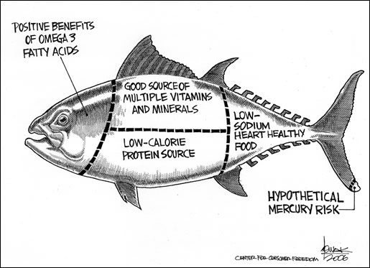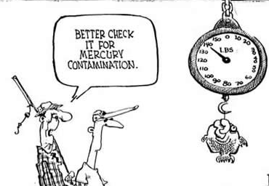
http://www.consumerfreedom.com/tag/cartoon/page/6/ | http://www.voiceoffreedom.org/archives/health/mercury/mercury-fish-infants.html
Document Overview:
Description of Activity
Part I. Introduction: What is Mercury Methylation?
Part II. Biomagnification
Part III. Data Interpretation of MMHg in Minnesota Lakes & Rivers
Part IV. Research of Mercury & Human Body Systems

Minnesota State Science Standards:
9.1.1.1.2 Understand that scientists conduct investigations for a variety of reasons, including: to discover new aspects of the natural world, to explain observed phenomena, to test the conclusions of prior investigations, or to test the predictions of current theories.
9.1.3.1.1 Describe a system, including specifications of boundaries and subsystems, relationships to other systems, and identification of inputs and expected outputs
9.1.3.4.4 Relate the reliability of data to consistency of results, identify sources of error, and suggest ways to improve data collection and analysis
9.4.2.2.2 Explain how matter and energy is transformed and transferred among organisms in an ecosystem, and how energy is dissipated as heat into the environment.
9.4.4.1.2 Describe the social, economic and ecological risks and benefits of changing a natural ecosystem as a result of human activity
9.4.4.2.4 Explain how environmental factors and personal decisions, such as water quality, air quality, and smoking affect personal and community health.
9C.2.1.2.6 Describe the dynamic process by which solutes dissolve in solvents, and calculate concentrations, including percent concentration, molarity, and parts per million.

Objective:
- The student will understand and be able to explain where mercury is found and how it becomes a part of an organisms body chemistry;
- the student will simulate biomagnification in a lab;
- the student will be able to interpret real data and maps related to the different concentrations of mercury found in the various oceans;
- the student will research and explain what happens when the mercury level becomes a part of the human diet; and, what happens to developing systems of a fetus.

Type of Activity:
This activity has a teacher generated, open discussion format, graphing/inquiry/mapping activity, and independent student research.

Duration:
3-4, 45 minute class periods (depending on class needs and grade level)
- Part I – 1 class period
- Part II – 1 class period
- Part III – 1 class period
- Part IV – 1 class period + individual time

Connection to Nobel speakers:
Overall, this activity sets up the fundamental knowledge necessary to understand where mercury is coming from naturally, and how it affects food chains, food webs, and, ultimately, humans.
Speaker:
- Dr. William Fitzgerald, a native Bostonian, Fitzgerald received his B.S. and M.S. degrees in chemistry from Boston College and the College of the Holy Cross, respectively. In 1970 he earned the first Ph.D. granted in a joint Woods Hole Oceanographic Institute/Massachusetts Institute of Technology chemical oceanography program. In that same year, he joined the faculty at UConn, where he has had almost continuous NSF funding for his research. In 2003 he received the Geochemical Society’s Patterson Award for his contributions to environmental chemistry, and in 2011 he was honored with the first Kathyrn R. Mahaffey Lifetime Achievement Award in Mercury Research.

Recommended Prior Knowledge:
Students should have a basic understanding of ocean chemistry, food webs, the ocean floor, volcanic emissions, and human development.

Concepts, Connections, and Terms addressed in the activity:
- Ocean chemistry
- Matter cycles
- Food chains
- Biomagnification

Materials:
- Part I
  - computer, projector, screen
- Part II
  - pasta (neutral and colored to represent mercury), plastic bags (1 per student), large area
- Part III
  - computers for 1-2 students, map of Minnesota, colored pencils,
- Part IV
  - individual computers for research

Description of Activity:
The key part of this four part activity is to understand how mercury is getting into our oceans and freshwater; and, how it is being taken up by fish and how it affects their food webs; how humans ingest it and what it does to humans.

Procedure:
Part I Introduction
1. Review oceans biomes (organisms that are found there, mineral content, general oceanography)
2. Generate discussion on how humans use and maybe exploit the organisms and resources that live or are found there.
3. Show 15 minute TedTalks clip by Stephan Palumbi, Following the Mercury Trail
http://www.ted.com/talks/lang/en/stephen_palumbi_following_the_mercury_trail.html
4. Discuss where mercury might be coming from naturally and human made.
5. Go over methylation of mercury using the following interactive websites:
http://www.whoi.edu/oceanus/viewArticle.do?archives=true&id=79706
http://www.whoi.edu/oceanus/viewFlash.do?fileid=69207&id=47275&aid=79706
6. Use several formative assessment, based on teacher and grade comfort level, (short but specific) to gauge their individual understanding of the methylation of mercury.

Part II (lab/simulation)
1. Distribute pasta (most neutral color and about 1/4 multi-color) within a large open space (indoor or outdoor).

2. Identify one or two people (depending on size of group) as a Great Blue Heron, Osprey, Eagle or Fisherman/woman and have them stand at one end of the playing area. Divide the remaining people into 1/3 large mouth bass and 2/3 zooplankton. In a group of 26 people, there would be two “birds” or “fishers”, six “fish” and 18 “zooplankton.” Have each set of people easily identifiable with bandannas, signs with pictures around neck, etc.

3. Distribute a small paper/plastic bag to each student representing a zooplankton - the bag is to represent the gut of each animal. Review with students that zooplankton are microscopic animals that have structures that allow them to capture food (phytoplankton (producers) or other zooplankton and bacteria); thus, zooplankton represent primary consumers in this food chain.

4. Give the following instructions: The zooplankton will be the first to look for food. The fish, bird(s) and fisher(s) should wait during this time. At a given signal, the zooplankton enter the area and collect as much food (pasta) as they can, placing the food into their bags. At the end of a short time period (30 sec.) depending on the size of the area, direct zooplankton to stop searching for food.

5. Next, allow the fish to search for food (zooplankton) for approximately 15 seconds or longer depending on the size of the area. Zooplankton can continue to eat until caught. Birds (or fishers) should still wait off to the side. Each fish should have time to catch one or more zooplankton. Any zooplankton tagged or caught by a fish must give his/her bag to the fish and then proceed to the sidelines. Review with students that these fish represent secondary consumers in this food chain.

6. Next, allow the birds (or fishers) to catch the fish. The same rules are followed. Any fish still alive may hunt for zooplankton. If a bird catches a fish, the fish must give his/her bag(s) to the bird/fisher and then proceed to the sidelines. Review with students that these fishers represent tertiary consumers in this food chain. At the end of the time period, ask all participants to come together in a circle with their bags of collected food.

7. Ask any participants holding bags to count the total # of colored pasta pieces they ingested. For each animal represented in the food chain, record the number of colored pasta pieces ingested on an overhead or dry erase board so everyone can see the results.

8. Next, inform students that the colored pasta pieces represent Mercury. Any surviving animal that has colored pasta now carries Mercury in their fatty tissue (where Mercury is stored). Notice that the fish should have more Mercury than the zooplankton, and the birds/fishers should have even more. This is called biomagnification.

9. Each student answers the following questions on biomagnification:
- What are trophic levels?
- Estimate the average Hg concentration in ppm (give them an initial number that the zooplankton will ingest) for a fish from trophic level 3 and explain your reasoning.
- Describe the general trend in this food chain; what is happening to the concentration of Hg as the trophic level increases?
- Explain why it would be safer to eat an organism from trophic level 2 than from trophic level 4, even if they were the same size.
- What happens to the Hg when a fish from trophic level 4 dies?
- Why do the phytoplankton have less levels of Hg?

Part III.

1. Lead off with the YouTube video on Biomagnification!, (this could be shown at any time)
http://www.youtube.com/watch?v=E5P-UoKLxlA

2. Have each student use the following website to calculate their own personal intake of mercury based on their diet.
http://www.nrdc.org/health/effects/mercury/calculator/start.asp
Discuss whole class results.

3. Give each student a copy of the Student Pages--Activity 3 with colored pencils and have them follow directions for it.

Part IV.
1. Working alone (or however it works best for your class) research the effects of mercury in humans in at least one human body system. Present in either paper, poster, or powerpoint (prezi, etc) the specific effects found in humans, with at least one citing of the developing fetus.
**The format in which the research is presented is at the teachers discretion.

Assessment:
Teachers can do many small formative assessments to gauge student comprehension. They can also turn into answers to questions about labs, graphs, and a research report.

Extensions:
Students who fish locally can research the lake and freshwater fish mercury and other heavy metals in those lakes and fish.

Other Links:

http://www.pbs.org/now/science/mercuryinfish.html
http://oceanexplorer.noaa.gov/edu/learning/player/lesson13/l13la1.html (interactive feed the ducks activity)
http://www.oehha.ca.gov/fish/hg/index.html
http://marinesciences.uconn.edu/
http://geoweb.princeton.edu/research/tracemetals/pdf/Kraepiel2003.pdf
http://www.nature.com/news/2009/090331/full/news.2009.218.html
http://www.cdc.gov/mmwr/preview/mmwrhtml/mm5343a5.html

Name: __________________________________________ MN Area: ___________________________
Student Guide Activity 3
Working in groups of 2-4, each student takes an area of Minnesota to "map" (see map of Minnesota on next page). Use the data from the following chart and from the Minnesota DNR LakeFinder resource to map out the Lowest to Highest Mercury contamination of fish in MN waters.
This website gives the type of consumption advisory: http://www.dnr.state.mn.us/lakefind/index.html This website gives the level of mercury that corresponds to the consumption advisory: http://www.health.state.mn.us/divs/eh/fish/eating/mealadvicetables.pdf
Procedure:
- Look up a lake and determine the type of fish which there are advisories and what the advisory is (how much can be eaten by whom).
- Use the second website to determine what the level of mercury is in the fish in question based on the advisory.
- Use the chart to determine the level of omega-3 fatty acids (Does the mercury level you found correspond with the chart?)
- Label the lake on the map below with the lake name (estimate the location based on county name). With the label include a list of the fish for which there are consumption advisories, and the omega-3 fatty acid and mercury levels in that fish. Do this for three lakes.
Chart (please note walleye belong the Perch Family):
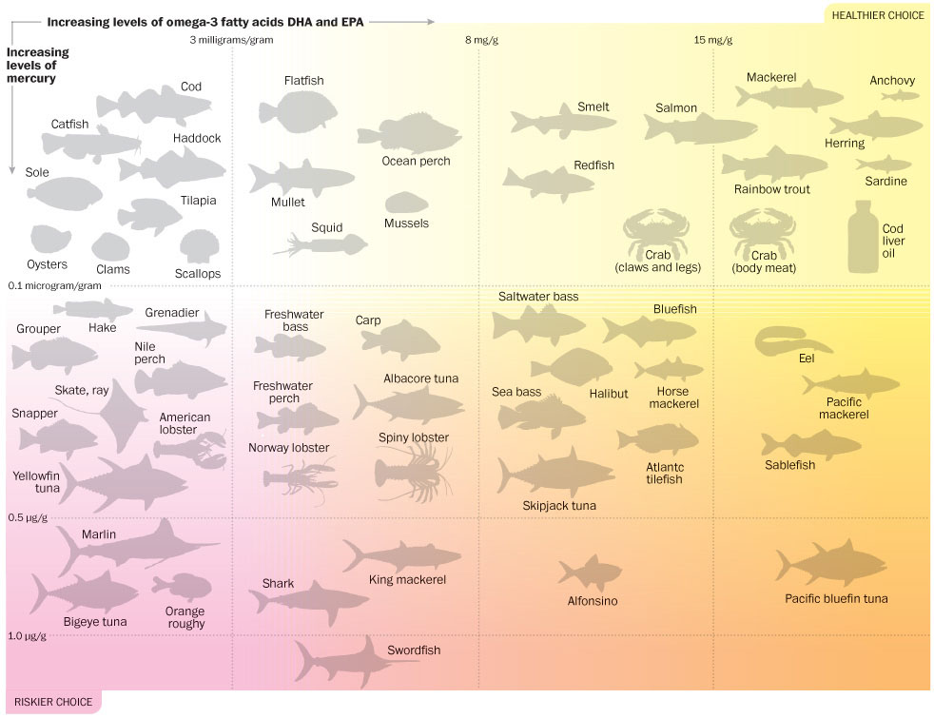
See http://www.washingtonpost.com/national/health-science/2012/04/03/gIQABd16sS_graphic.html for a larger version of the chart
This map is in the public domain and can be found at: http://commons.wikimedia.org/wiki/File:Minnesota-counties-map.png
