Build Your Own Bluefin!
Engineering a Model for Counter-Current Heat Exchange
*Adapted from: C. Loudon, E. C. Davis-Berg, J. T. Botz. A Laboratory Exercise Using a Physical Model for Demonstrating Countercurrent Heat Exchange. Adv Physiol Educ 36: 58–62, 2012.
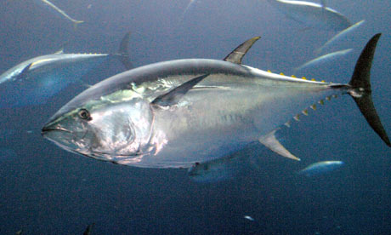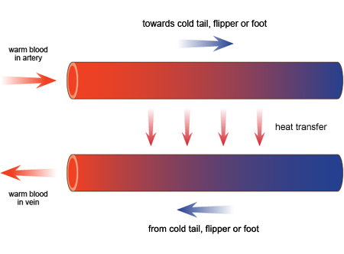
Source: http://www.guardian.co.uk/ Source: www.bbc.co/uk
Document Overview: This lesson is meant to show students in a hands-on, inquiry-based activity the process of heat exchange in animals, specifically counter-current heat exchange. The culmination of this activity is for students to understand how Bluefin Tuna and other endothermic species regulate their internal temperature, which is directly related to the research that Dr. Barbara Block is performing.

Minnesota Academic Standards in Science:
9.1.1.2.1 Formulate a testable hypothesis, design and conduct an experiment to test the hypothesis, analyze the data, consider alternative explanations and draw conclusions supported by evidence from the investigation.

9.1.2.1.1 Understand that engineering designs and products are often continually checked and critiqued for alternatives, risks, costs and benefits, so that subsequent designs are refined and improved.

9.1.2.2.1 Identify a problem and the associated constraints on possible design solutions.

9.1.2.2.2 Develop possible solutions to an engineering problem and evaluate them using conceptual, physical and mathematical models to determine the extent to which the solutions meet the design specifications.

9.1.3.1.1 Describe a system, including specifications of boundaries and subsystems, relationships to other systems, and identification of inputs and expected outputs.

9.1.3.1.3 Describe how positive and/or negative feedback occur in systems.

9.1.3.4.6 Analyze the strengths and limitations of physical, conceptual, mathematical and computer models used by scientists and engineers.

9.4.1.1.1 Explain how cell processes are influenced by internal and external factors, such as pH and temperature, and how cells and organisms respond to changes in their environment to maintain homeostasis.

9.4.1.1.2 Describe how the functions of individual organ systems are integrated to maintain homeostasis in an organism.

9.4.3.3.5 Explain how competition for finite resources and the changing environment promotes natural selection on offspring survival, depending on whether the offspring have characteristics that are advantageous or disadvantageous in the new environment.

Objective: To develop an understanding of the thermal regulation system of endothermic animals by constructing a physical model of a thermo-vascular system.

Type of Activity: Lab Investigation or Classroom Demonstration

Duration: One or two 45 minute class periods

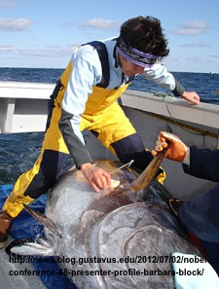
Connection to Nobel Speakers:Marine Biologist Dr. Barbara Block has developed the Tuna Research and Conservation Center to study how large pelagic fish move around in the open ocean. In addition, she has expertise in understanding the thermal regulation systems of tuna that allow them to successfully move through significant variations in water temperature.

Teacher Tips: Depending upon available resources and time, this activity can either be performed as a lab exercise or as a class demonstration. It is
recommended that students have at least a basic understanding of methods of heat transfer, ectothermic vs. endothermic species, and counter-current versus concurrent heat exchange before starting this activity. In terms of timing in relation to the 2012 Nobel Conference, this activity can either be done before or after watching Dr. Blocks presentation.

Concepts covered in this lesson:
- Counter-current heat exchange
- Transfer of thermal energy
- Ectothermic vs. endothermic species
- Circulatory system
Description of activity: In this activity, students will be constructing a physical model of a heat exchanger in which they will be directly observing the differences between counter-current heat exchange and non-countercurrent heat exchange.

Materials:
- 2 Five-gallon buckets
- One plastic crate to support hot water supply reservoir
- 1 insulated jug for ice water
- ice supply
- hot water supply, ideally a hot water faucet of constant temperature
- dialysis tubing, 1" (which refers to the width when dry)
- Carolina Biological Supply Co, 1in x 50' part#684214. $25.95 ea
- Use about 14' of tubing for the concurrent system, and
about 17' for the counter-current system.
- 1 @ nylon hose barb 1/2" ID x 3/4" MIP (threaded).
Menard's part #680-6732 $1.96 ea
- 1 @ rubber stopper to plug hose barb in bottom of bucket
- 1 @ 2 1/4" rubber washer.
Menard's part #674-6973 $1.10ea
- 1 @ 3/4" FIP brass lock nut.
Menard's part #680-6091 $2.99 ea
- 1 @ 3/4"x10' thin wall conduit.
Menard's part #689-9684 $1.19 ea
- 6 @ 3/4" sch40 90 degree conduit bend.
Menard's part #365-3003 $0.77 ea
- Several small zip-ties or one 1/2” hose clamp

Activity:
1) To start the activity, it is recommended that you show a TED Talk video titled Tagging Tuna in the Deep Ocean: http://www.ted.com/talks/barbara_block_tagging_tuna_in_the_deep_ocean.html
This is a great video in which Dr. Barbara Block discusses how large pelagic fish live and travel in the open ocean. Using novel electronic tags, Block and her team track large predators — tunas, bill fish and sharks — on their ocean journeys. She also describes how and why muscle makes heat at a molecular level in fish, which is the focus of this lesson.

2) After watching Dr. Block’s Ted Talk, you may wish to have students read the article Warm Fish With Cold Hearts: Thermal Plasticity of Excitation-Contraction Coupling in Bluefin Tuna, Proc. R. Soc. B (2011) 278, 18–27:
http://rspb.royalsocietypublishing.org/content/278/1702/18.full.pdf+html
This is an article in which Dr. Block describes exactly how Bluefin tuna and other endothermic species are able to conserve heat in their locomotory muscle, viscera, eyes and brain, yet their hearts operate at ambient water temperature. A nice take-home assignment could be to have students read the abstract of the article and discuss the following day.

3) Whether you chose to have students read the Warm Fish With Cold Hearts article or not, it is recommended that you have a discussion with your students about Ectothermic species compared to Endothermic species.

4) Next, construct a model for counter-current versus non-countercurrent heat exchange. Described in this material is an example of a system that was constructed as a gravity-fed model. A gravity-fed ﬂow is smooth, but the reservoir must be replenished regularly and/or must be fairly large so that the ﬂow rate does not decrease significantly as the liquid level in the reservoir falls. A gravity-fed system has the advantage of being lower cost than setting up a pump driven system.

The figures below shows a home-built gravity fed heat exchanger we constructed with dialysis tubing and common hardware store materials. A plastic pipe fitting is affixed to a large container (5 gallon bucket or large tub). Water is fed from the warm reservoir through the heat exchanger and into a bucket of ice water, simulating the cold ocean water passing over the gills of the tuna. This water, after being chilled, passes back through the heat exchanger and then into a collecting basin.

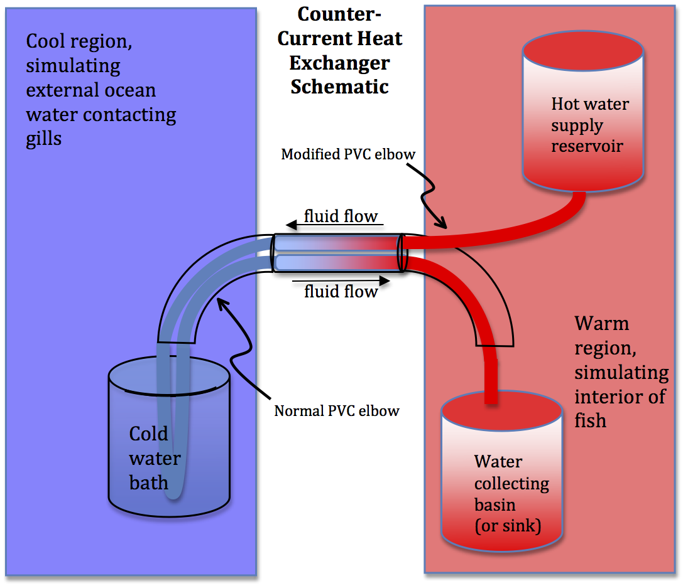
Fig. 1 shows a schematic for a counter-current heat exchanger. In this schematic, the hot water is representing the warm arterial blood getting pumped out of the heart and heading to the gills, which is represented by the cold water basin. The returning fluid out of the cold water basin is representing the cool venous blood exiting the gills and heading back to the heart. The different color gradients in the heat exchanger are meant to illustrate the exchange of heat via conduction, which is what occurs in endotherms such as bluefin tuna. In a counter-current system such as this, the fluid obtained in the collecting basin is at a temperature that is not significantly different than the fluid in the supply reservoir. There is thermal exchange in this system to cool the fluid leaving the warm region and warm the fluid leaving the cool region.

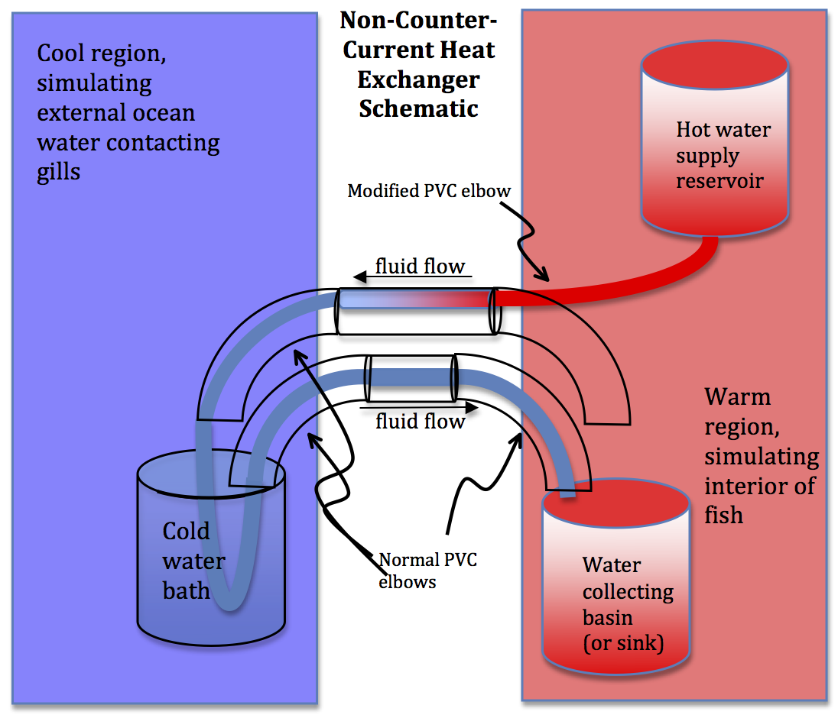
Fig. 2 shows a schematic for a non-countercurrent heat exchanger. Just as in Fig. 1, the hot water is representing the warm arterial blood getting pumped out of the heart and heading to the gills, which is represented by the cold water basin. The returning fluid out of the cold water basin is representing the cool venous blood exiting the gills and heading back to the heart. In this case, the fluid entering the water collecting basin is at a lower temperature as compared to the fluid collected from the counter-current system. There is no thermal exchange in this system to cool the fluid leaving the warm region and warm the fluid leaving the cool region.

Procedure for Constructing a Gravity-fed Counter-current System

Creating the supply bucket for hot water  Drill a 1” diameter hole at the bottom of a 5 gallon bucket  Insert the nylon hose barb through from the outside of the bucket, and then place the rubber grommet and brass nut on the threaded side inside of the bucket. | 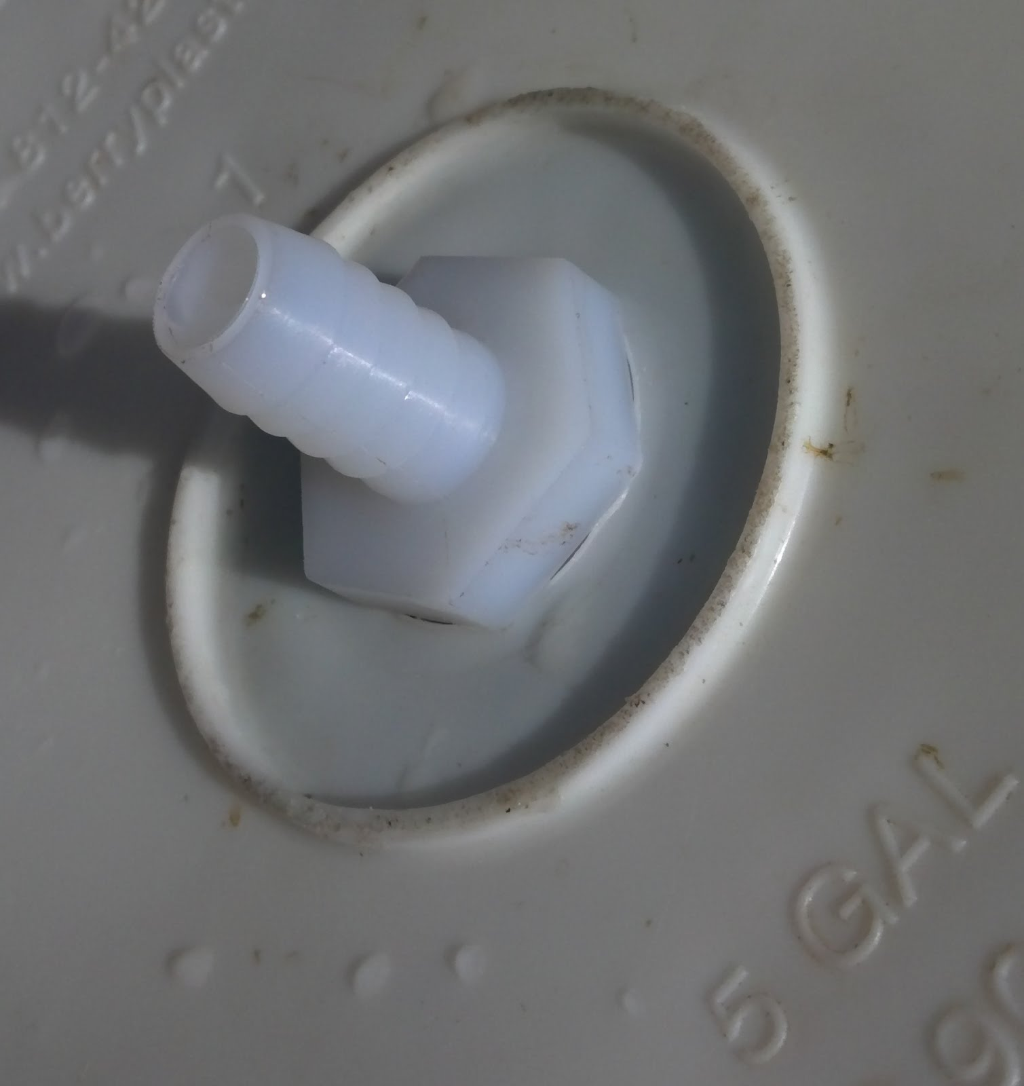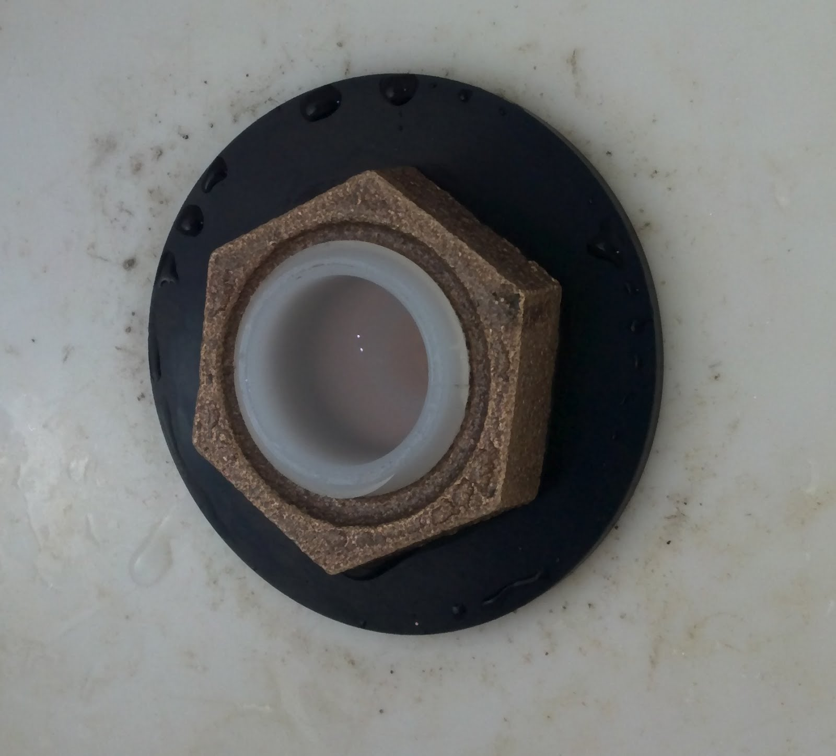
Constructing the heat exchanger  One of the PVC elbows must be modified to act as a Y connector. Using a handsaw, trim away the top half of the pipe at the flared end to allow one piece of tubing to continue straight while another follows the bend of the pipe. One of these pieces will need to be created for each exchanger to be constructed. In this photo, note the dialysis tubing that leaves the hot water bucket enters the elbow through the region that has been removed. | 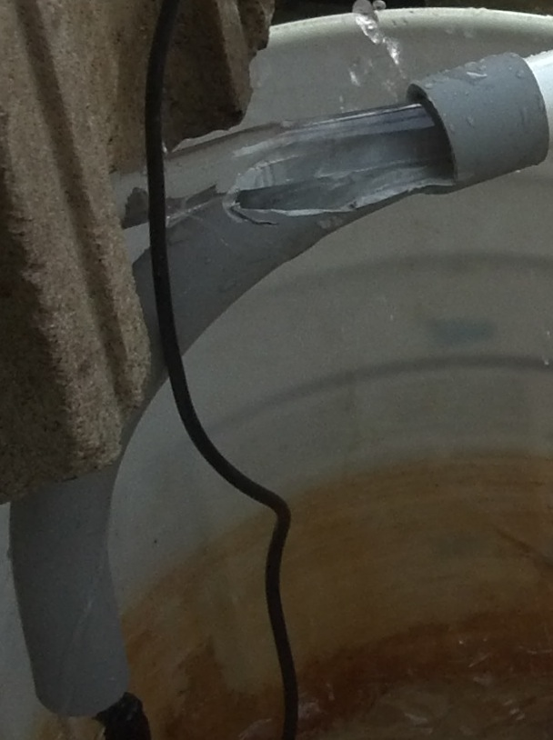
The exchanger will be constructed of two elbows attached to each end of a section of thin walled ¾” PVC pipe. Cut an 18” length of pipe for the exchanger, realizing this measurement can be adjusted as desired by the experimenter. Prepare to assemble the three pieces as the tubing is threaded through them. | 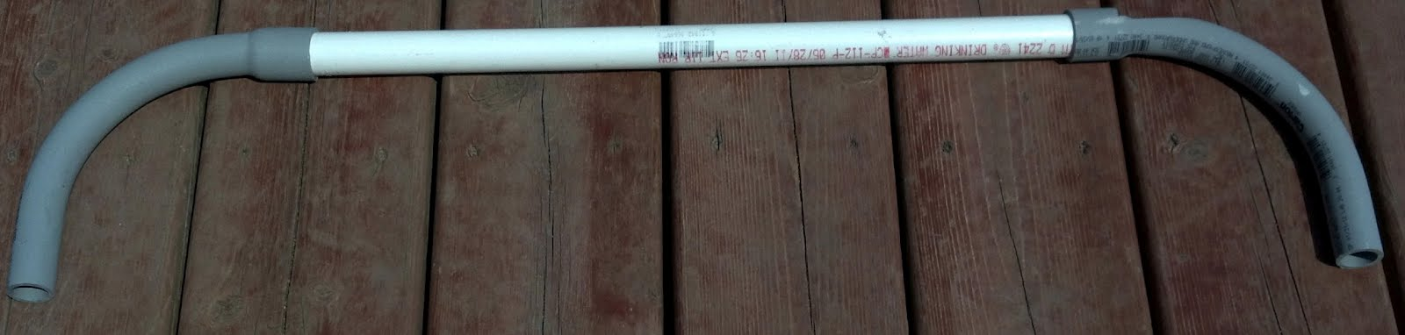
Cut an approximately 14’ section of dialysis tubing from the roll. Place it under water for about one minute to allow the tubing to become more pliable. Gently roll one end of the tubing between your thumb and finger to open the tubing.
Once the tubing has soaked, gently thread it through the pipes. Follow the path illustrated in the counter current schematic (Fig 1), realizing that there is an elbow on each end of the exchanger to prevent the tubing from bending too abruptly and restricting the water flow. It may be necessary to use a long, thin piece of material like a wooden dowel to push the tubing through the pipe.  It might be easiest to start at the water collecting basin and thread the tubing backwards through the system. This can minimize the amount of tubing to be pulled through the modified fitting that may have slightly sharp edges. | 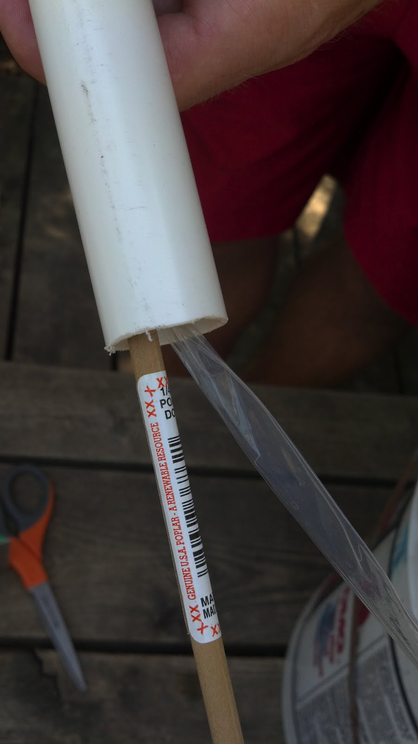
Carefully connect the elbows to the straight PVC pipe, being cautious not to pinch the dialysis tubing in the joints.  Be cautious to keep the tubing passing through the exchanger straight and without twists to maximize the potential for thermal exchange between the fluid in each section of the tube.  Keep a loop of tubing available to pass through the ice water bath simulating the cool water on the tuna’s gills (note the clear dialysis tubing loop coming from the PVC pipe, into the water bath, and back in this photo). Make sure to check for flow restrictions, such as twisting and severe bending, as this will limit the flow of water through the system. | 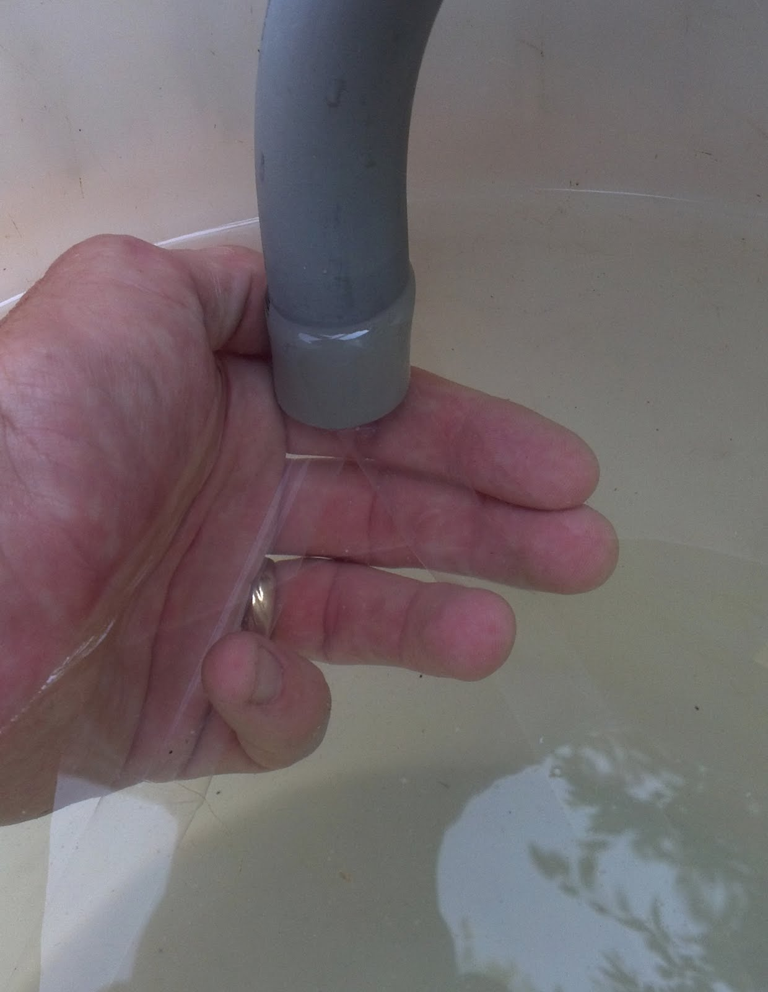
Place the hot water supply reservoir on top of a plastic crate so that the hose barb protrudes through a hole in the crate. | 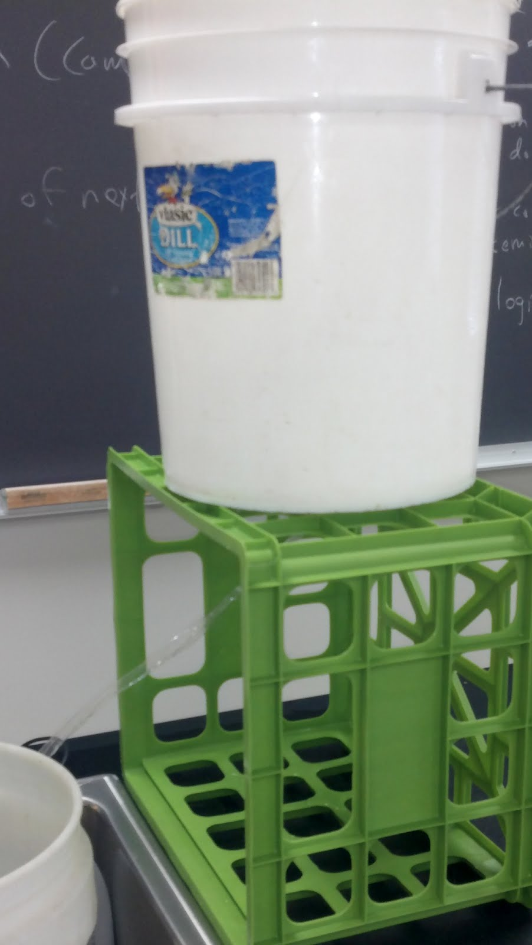
Route the dialysis tubing that comes through the top of the modified PVC elbow up through the crate to the hot water supply reservoir. Carefully slide the open end of the tubing as far up onto the hose barb as you can. Secure it with a plastic zip tie or an appropriate hose clamp. (It may be wise to put a cup or towel under the hose barb connection to collect any leaking water that may result) | 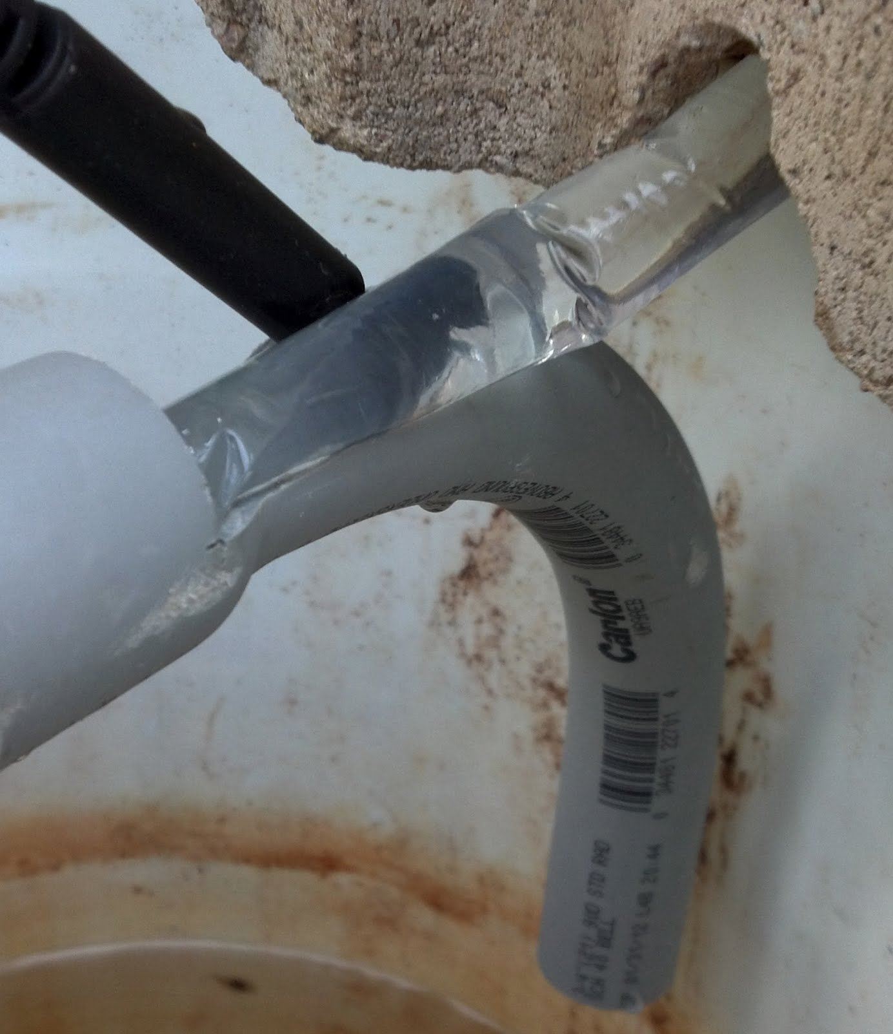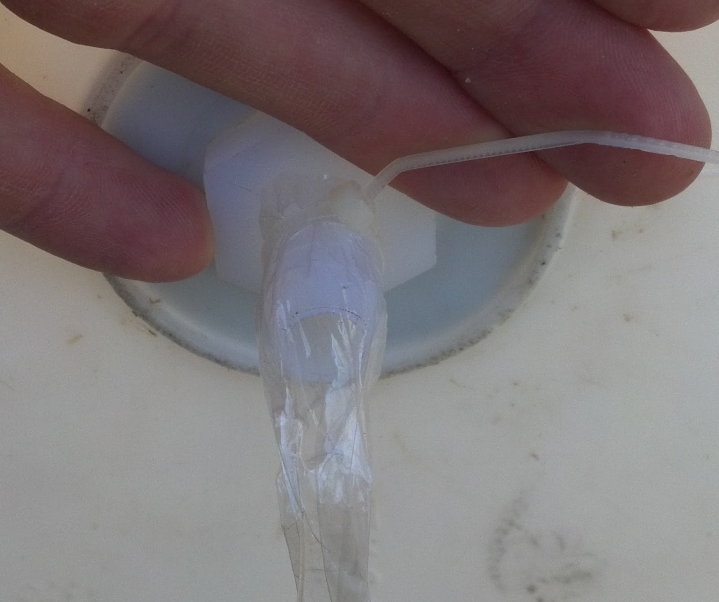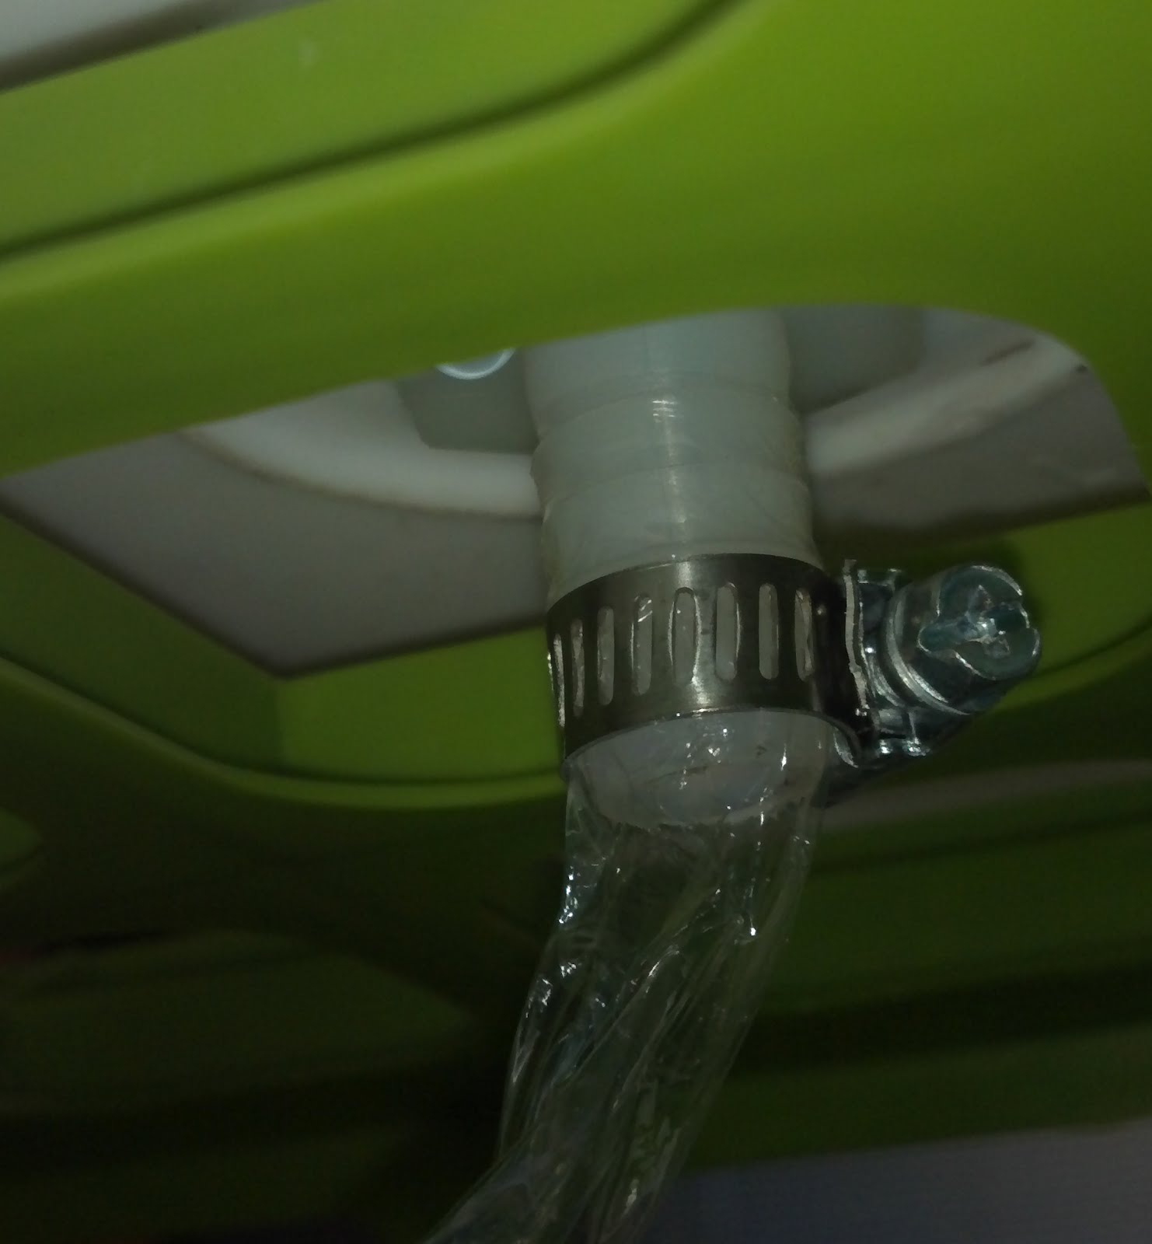
Place a temperature probe or thermometer in the hot water supply reservoir to monitor the temperature of the warm water as it leaves the bucket. Place a second temperature probe in the water stream as it exits the system into the collecting basin (or a sink works well if inside). Place a significant amount of ice cubes in to the cold reservoir (an insulated drink cooler works well). Maintain some stirring in this cold water bath during the experiment to assure continued cooling of the simulated blood flowing through the system.  Use a rubber stopper to prevent the flow of hot water out of the supply until the experiment is to be started.  Begin the water flow and assure that there is a steady flow. Record the values of the temperatures on the data table at several points in time during each run. | 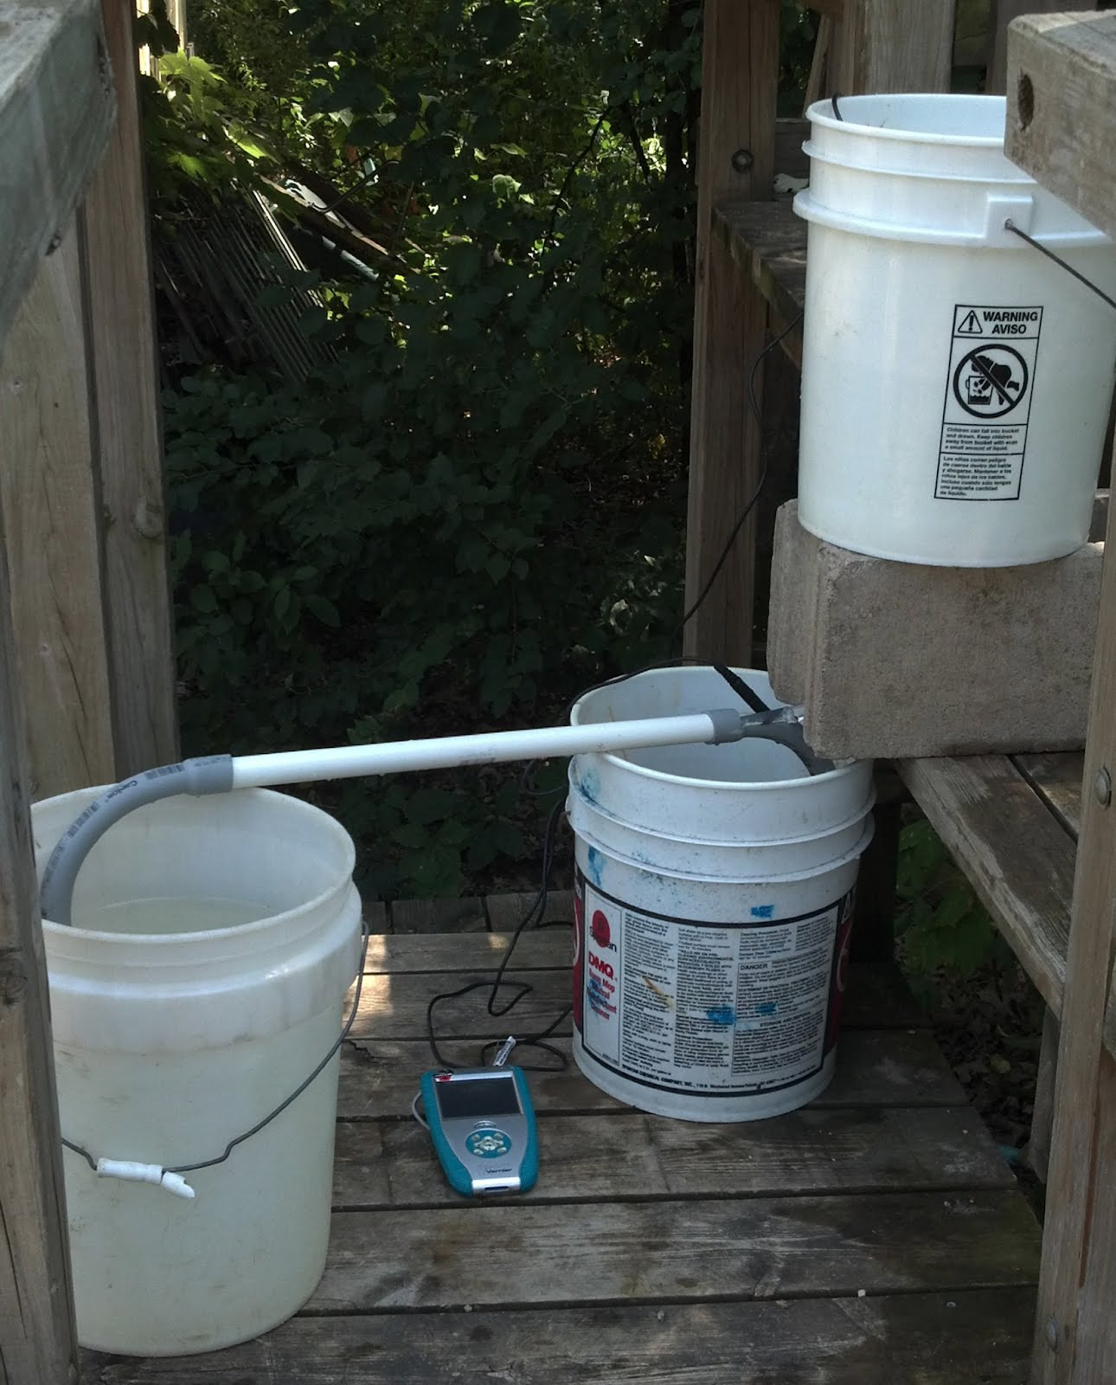

Procedure for Constructing a Gravity-fed non-countercurrent System

Begin by creating another exchanger out of 18” PVC pipe with two PVC elbows. Pull out the section of tubing that served as the drain in the counter-current system until you reach the cold water bath. Then, pass the tubing through the new section of PVC pipe and into the water collecting basin. You should now have a system similar to the counter-current model, except in this case there are two pipes side-by-side.

Students setting up this model can collect data to illustrate the different effectiveness of these two systems. They key difference between the systems is the way the heat is exchanged.
In the counter-current system, the temperature differential between the moving fluids is maximized...causing a significant thermal energy transfer from the hot fluid to the cold fluid within the exchanger. The energy that is transferred from the warm to the cold fluid quickly returns to the system as the cold fluid is re-entering the warm region. This design minimizes the amount of thermal energy lost to the outside. By allowing significant thermal energy transfer between the flowing fluids, a substantial difference of temperature can remain between the warm and cool ends of the heat exchanger. In the case of the tuna, this is what allows the animal to maintain as much thermal energy as possible while swimming in very cold water for limited periods of time. One may choose to wrap an insulating material around the outside of the horizontal pipe in the heat exchanger.

In the non-concurrent system, there is no opportunity for thermal energy to be exchanged form the warm fluid to the cool fluid. Again, one may choose to wrap an insulating material around the outside of each of the two horizontal pipes in this heat exchanger.

If one set up a concurrent system, the fluid in each part of the exchange would flow in the same direction. In this case there would be a larger difference in temperature between the warm fluid entering the exchanger and the cold fluid also entering the exchanger but traveling the same direction. This greater difference causes a significant amount of thermal energy to transfer from the warm fluid to the cold fluid. The disadvantage of this system is that once the thermal energy has transferred to the cold fluid, this energy is not recovered as the cold fluid in the heat exchanger is collected in the basin. If this were to happen in a bluefin tuna, the fluid would be returning back to the heart at a significantly lowered temperature, which would lower the overall internal temperature which could prove to be fatal for the fish. This is why bluefin tuna and other ectotherms have a concurrent heat exchanger so that they can maintain their internal body temperature without having to expend additional energy!

All models have limitations. This particular water based model does not demonstrate the closed nature of the vascular system of the fish. As a closed fluid system, the fish’s body has to provide energy to re-warm blood entering the heart muscle before it flows through the system again. The difference between the temperatures of the original warm water and the final cold water in this model can illustrate the relative amount of energy demanded of the fish in both cases.

In terms of data collection, the easiest way to measure the temperature of the fluid is to measure the starting temperature of the fluid in the supply reservoir and also measure the temperature of the fluid in the collecting basin. You may wish to add Styrofoam chips to the collecting basin to limit the amount of heat exchanged with the air in the room. This can be accomplished with either thermometers or electronic temperature probes, depending upon resources available. If desired, one could also measure the temperature at different locations in the heat exchanger, but it would involve inserting thermocouples at various locations in the tubing system. Students can get a qualitative impression of the heat exchanger gradient by simply holding the dialysis tubing on the warm and cool sides between their ﬁngers (before wrapping it in insulation). It is worth noting, however, that the water in the cold water bath be circulated with either a person simply stirring the water or by having a stir bar rotating at a generous speed to keep the ice water moving; otherwise, the water immediately surrounding the tubing will warm up and no longer adequately chill the water ﬂowing through it.

Acknowledgements

C. Loudon, E. C. Davis-Berg, J. T. Botz. A Laboratory Exercise Using a Physical Model for Demonstrating Countercurrent Heat Exchange. Adv Physiol Educ 36: 58–62, 2012.

Block, Barbara. Tagging Tuna in the Deep Ocean. http://www.ted.com/talks/barbara_block_tagging_tuna_in_the_deep_ocean.html

H. A. Shiels, A. Di Maio, S. Thompson,and B. A. Block. Warm fish with cold hearts: thermal plasticity of excitation–contraction coupling in bluefin tuna. Proc. R. Soc. B (2011) 278, 18–27.

Counter-current vs. non-Countercurrent Heat Exchange
Student Data Sheet

1) Objective: To develop an understanding of the thermal regulation system of endothermic animals by constructing a physical model of a thermo-vascular system.

2) Hypothesis: ________________________________________________________________
___________________________________________________________________________.

3) Data:
Part I: Counter-current Heat Exchanger
 | A | B | C
 | Average temp. of water collected  (oC) | Average starting temp. of water  (oC) | Difference in water temp  [column A - column B] (°C)
Trial 1
Trial 2

Part II: non-Countercurrent heat exchanger
 | A | B | C
 | Average temp. of water collected  (oC) | Average starting temp. of water  (oC) | Difference in water temp  [column A - column B] (°C)
Trial 1
Trial 2
4) Analysis:
- Which heat exchange system resulted in the greatest difference in water temperature? _____________________________________________________________________
Explain why:___________________________________________________________
______________________________________________________________________
______________________________________________________________________
- Based upon your results, which heat exchange system is better suited for a bluefin tuna? _____________________________________________________________________
Explain why:___________________________________________________________
______________________________________________________________________
______________________________________________________________________
- Research: What are some other examples of counter-current exchange that happens inside living species? (Hint: one example of this is a process actually happening inside of you right now!) ______________________________________________________
_____________________________________________________________________
____________________________________________________________________.
- What are some improvements that could be made to either model to better illustrate the process of heat exchange? _____________________________________________
______________________________________________________________________
______________________________________________________________________.

- What are some limitations to these models? ___________________________________________________________________
______________________________________________________________________
______________________________________________________________________.

