Discovering Plate Boundaries
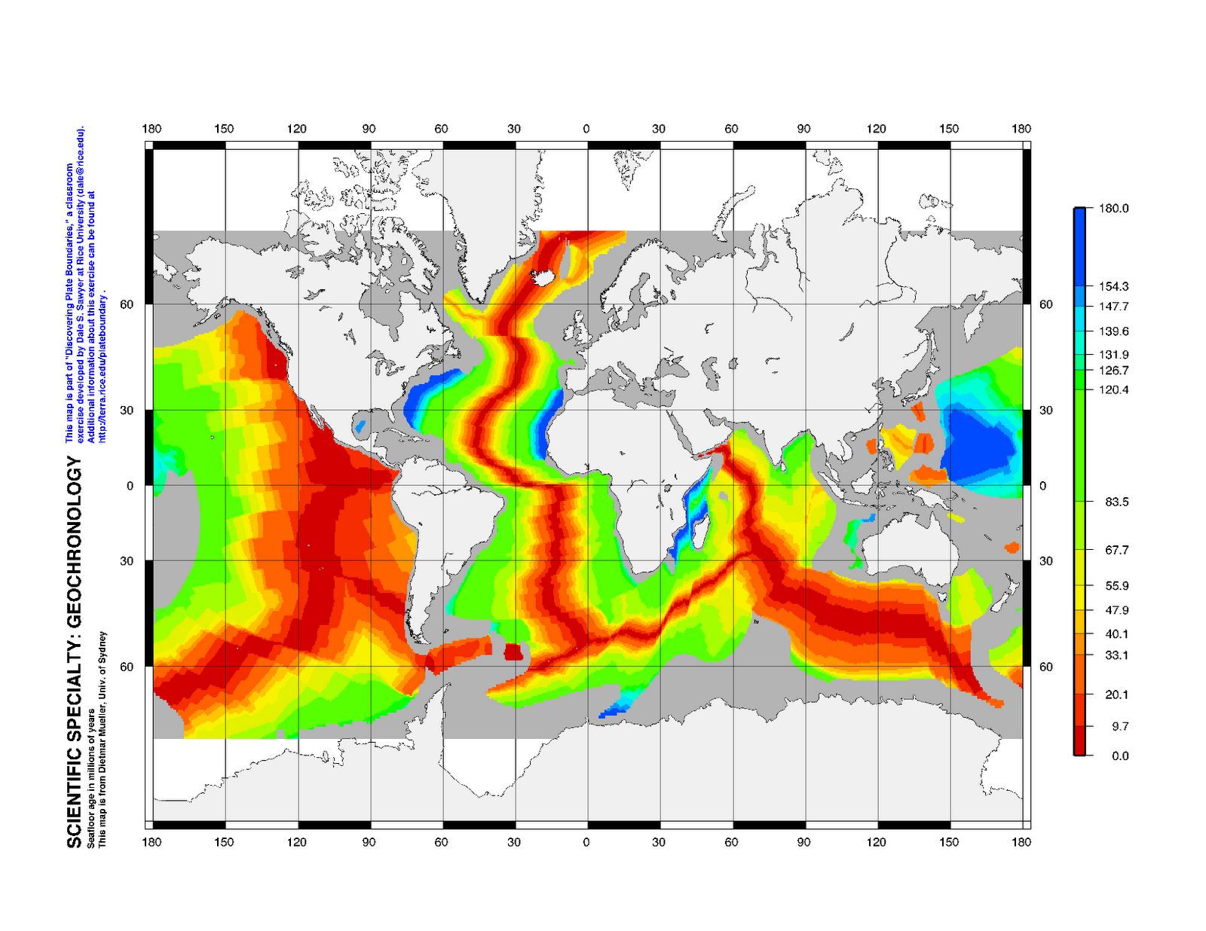
Document Overview:
Teacher instructions for Periods 1, 2, & 3
Student instructions
Assessments notes

Minnesota Science Standards:
9.1.1.1.2 Understand that scientists conduct investigations for a variety of reasons, including: to discover new aspects of the natural world, to explain observed phenomena, to test the conclusions of prior investigations, or to test the predictions of current theories.
9.3.1.1.1 Compare and contrast the interaction of tectonic plates at convergent and divergent boundaries.
9.3.1.1.2 Use modern earthquake data to explain how seismic activity is evidence for the process of subduction.
9.3.1.1.3 Describe how the pattern of magnetic reversals and rock ages on both sides of a mid-ocean ridge provides evidence of sea-floor spreading.
9.3.1.1.4 Explain how the rock record provides evidence for plate movement.
9.3.1.l.5 Describe how experimental and observational evidence led to the theory of plate tectonics.
9.3.1.2.1 Use relative dating techniques to explain how the structures of Earth and life on Earth have changed over short and long periods of time.

Objectives:
- Students will be able to determine where the boundaries are between tectonic plates.
- Students will be able to determine what observations are useful for characterizing plate boundaries.
- Students will be able to determine what physical processes occur at plate boundaries.
- Students will build accurate content knowledge through their own observations, classifications, and descriptions.
- Students will build skills in group collaboration, written and oral communications.

Type of Activity:
This three part data map activity is written in a jigsaw cooperative learning design, but could be easily modified into a gallery walk or whole class format.

Duration:
Three 50 minute periods

Connection to Nobel Speaker:
Maya Tolstoy is a marine geophysicist and seismologist at Lamont-Doherty Earth Observatory. She researches mid-ocean ridge earthquakes, the links between earthquakes and life at hydrothermal vent systems, seafloor instrumentation, and the impact of anthropogenic noise on marine mammals. At Lamont-Doherty she is responsible for the design, execution, and analysis of marine seismic experiments. She has been part of 27 research cruises in the Atlantic, Pacific, and Indian oceans and the Mediterranean Sea.

Teacher Tips:
This activity is adapted from an article about Discovering Plate Boundaries, published in January 2005 in the Journal of Geoscience Education by Dale S. Sawyer, et. al. In this activity students are first divided into four groups. Each group will work with a specific set of data and become the “specialists” in their data field determining plate boundaries. They will later be reorganized into new groups containing a specialist from each data field to study the boundaries of one tectonic plate. The data is presented on maps available online at http://terra.rice.edu/plateboundary/intro.html as downloads or may be ordered as a kit. Large classroom maps for posting and small individual maps for student notations are available at http://terra.rice.edu/plateboundary/downloads.html. For Part I of this activity a student’s world map without plate boundaries marked may be used. Print this map located as slide #3 on the teacher’s guide part 2 power point. Final presentations by teams may be done as power point shows rather than using transparencies and overhead projectors. Two sets of data maps may also be used if class sizes are large to minimize crowding and maximizing participation for teams.
No previous knowledge of plate tectonics is needed. It is important that students do have some background information about earthquakes, volcanoes and be familiar with a world map of the continents and oceans. Students with some understanding of plate tectonics should be encouraged to see data as a key to the scientific process….letting the observations they make during their investigations drive their descriptions and classifications.
Finally, the teacher should be aware of the data contained on each map and expect to be actively working the room, visiting each group, and asking leading questions that might help guide their attention to patterns, anomalies, etc. This activity is presented using a jigsaw cooperative learning approach of student participation. If your student population or classroom configuration doesn’t lend itself to this method, it could easily be redesigned as a whole class activity, where everyone is working on the same data set at one time before moving on to the next set.

Concepts:
Plate tectonics
Plate boundaries
Seismology
Volcanology
Topography
Geochronology

Description of Activity:
This activity is considered a data rich exercise for discovering plate boundary processes.
It uses four specific types of maps of Earth’s surface illustrating earthquakes, volcanoes, topography and age of crust data. In Period 1 Specialist teams make observations to determine plate boundaries using their specific data map. They then classify their boundaries with descriptions provided by the data, noting patterns or anomalies. In Period 2 teams are reorganized so that each team is made up of a specialist from each data map area. A world map is provided and a tectonic plate is assigned to each group. Working as a team of four different specialists, the group focuses on their plate, identifying the types of boundaries and describing each boundary by the evidence provided by each specialist. Period 3 is reserved for team presentations and discussion of the scientific processes used by scientists to develop and/or challenge theories.
Materials:
Student and data maps available at http://terra.rice.edu/plateboundary/downloads.html
Seismology Data Map (24x36 inch) 1 per class
Volcanology Data Map (24x36 inch) 1 per class
Geography Data Map (24x36 inch) 1 per class
Geochronology Data Map (24/36 inch) 1 per class
Plate Boundary Maps (11x17 or 8.5 x11 inch paper) 2 per student
Plate Boundary Maps (8.5x11 inch transparency) 1 per 4 students
Tape for mounting maps 1 per class
Student Instruction Handout 1 per student
Colored Pencils, 5-6 colors 2-3 pencils per student
(The following may be used or team pages created for the SMART Board)
Transparency markers, non-permanent, 5-6 colors 1 set per 4 students
Overhead projector on Period 3 of the exercise 1 per class
Set of overhead transparencies for wrap up discussion 1 per class

Teacher Instructions:
Available as Parts I & 2 in a PowerPoint or PDF format. http://terra.rice.edu/plateboundary/tg.html
Student maps and instruction downloads available at http://terra.rice.edu/plateboundary/downloads.html

Discovering Plate Boundaries!
(Student Handout; Four Map Version)
Adaptation of modified work by David Heroy 1/24/06

Welcome to Discovering Plate Boundaries! This handout will guide you through the discovery process, where you learn about one of the great mysteries of the Earth using real scientific data!

Day 1: Assemble in four groups of Scientific Specialists (with your map)

You will need to divide up into four (4) groups. The teacher will help you with this. In each corner of the room will be one of the four scientific maps of the Earth, each with important scientific data on it. Each group will move to one of the four corners of the classroom Each person in that group will now be considered to be “Scientific Specialists” in one of these four sets of data.

Four Scientific Maps include:
1. Seismology (location and depth of earthquakes)
2. Volcanology (location and distribution of volcanoes)
3. Geography (3D surfaced of the Earth, both topography and bathymetry)
4. Geochronology (age of various rocks around the surface of the Earth)

Task 1. Look at your group’s map and discuss what you see. (Please avoid using scientific terminology or making interpretations!) Work as a group. Let everyone talk about what they see. For example, discuss the following:
What sort of data are you looking at?
What do the different colors indicate?
What are some examples of extreme data points/locations?
What are some patterns in the data?
Where is the data uniform and where is it highly varied?
What you look for will vary with which data map group you are in. For the point data (volcanoes and earthquakes) you are looking for distribution patterns. For surface data (topography and seafloor age) you are looking for where the surface is high and where it is low, where it is old and where it is young.

Task 2. Each student will be provided with (two copies of) a fifth map: The Plate Boundaries map. This map has lines that indicate the “known” location of the boundaries (edges) of the various plates that make up the Earth’s crust. Here is what you need to do:
Focus your attention on the plate boundaries. Identify the nature of your data near the plate boundaries. Is it high or low, symmetric or asymmetric (varying on one side of the boundary differently than on the other side), missing or not missing, varying along the boundary or constant along the boundary, etc. As a group, classify the plate boundaries based on your observations of your group’s data. Restrict yourselves to about 4-5 boundary types. At this point, do not try to explain the data; just observe!

Task 3. Assign a colored pencil (teacher; give the students colored pencils or crayons) color to symbolize each boundary type in your classification scheme. Mark the first Plate Boundary Map with the symbols you devised indicating your group’s boundary types. If the data vary on one side of the boundary but not on the other, devise a way of indicating that on your plate boundary map. Each person should mark the boundary types identified by the group on their own map. Each person should write down descriptions (please use complete sentences) of the group’s plate boundary classifications on the back of their own map. These maps and descriptions will be turned in at the end of the exercise.

Day 2: Assemble in your Plate Groups

Now we divide up into new groups, each group for a different tectonic plate. You will need to find a space somewhere in the room to group together. The teacher will help you with this. We can have as many groups as we like, but there must be at least 4 people in each group (i.e., one person from each specialty for each Plate Group).

The Plates Groups are:
1. North American Plate
2. Pacific Plate
3. African Plate
4. South American Plate
5. Eurasian Plate
6. Cocos/Nazca/Caribbean Plates
7. Australian Plate
8. Antarctic Plate
9. Indian Plate
10.Arabian Plate

Task 1. Each person should make a brief presentation to the rest of their group about their Scientific “Specialty’s” data and classification scheme. Your group may move to each map in turn while doing this or you may have smaller maps for each group to use.

Task 2. Compare the classifications of boundary type for your plate based on each type of data. Are there common extents (along the boundaries between the different classifications? Can your plate group come up with a new classification scheme that now includes data from all four Scientific Specialities? As above, assign a color to symbolize each of your plate boundary types. If a boundary is asymmetric, be sure to devise a way to represent the asymmetry.
Each person should mark the boundaries of your plate or plate grouping using your color scheme on your second Plate Boundary Map. Each person should write a description of the plate boundary classifications you have used on the back of their own map. These maps and descriptions will be turned in at the end of the exercise.

Day 3: Whole Class Discussion

One student from each Plate Group should make a presentation to the class. They should talk about their group’s plate boundary classification scheme and how they classify the boundaries of their plate. You will be given an overhead transparency of the Plate Boundary Map and some transparency markers to prepare for the presentation.

The instructor will conclude the exercise by summarizing the students’ observations and placing them in the context of accepted plate boundary types and plate boundary processes.

Or...power point presentations may be assigned to groups where all members may have a part sharing their Scientific Specialties.

To be turned in by each student after Day 3

1. Plate Boundary Map with classified boundaries using data from your assigned Scientific Speciality. Detailed descriptions (full sentences) of each plate boundary classification devised by your specialty group (along with the symbol for each classification) should be on the back of the map.

2. Plate Boundary Map with your assigned Plate Group boundaries classified using data from all four scientific specialities. Detailed descriptions (full sentences) of the plate boundary classifications devised by your plate group (along with the symbol for each classification) should be on the back of the map.

Discovering Plate Boundaries
Four Map Version
Student Handout

You have been (or will be) assigned to one of four Scientific Specialties.

The Scientific Specialties are:
A. Seismology
B. Volcanology
C. Geography
D. Geochronology

Each Scientific Specialty group has been provided a world map showing data relevant to
locating plate boundaries and understanding plate boundary processes. Each student will
be provided two Plate Boundary Maps. You will mark these as described below and turn
them in at the end of the exercise. There are a number of colored pencils available in the
room for your use.

Period 1: Assemble in your Scientific Specialty groups with your group's map

Task 1. Look at your group's map and talk about what you see. What you look for will
vary with data type. For the point data (volcanoes and earthquakes) you are looking for
distribution patterns. For surface data (topography and seafloor age) you are looking for
where the surface is high and where it is low, where it is old and where it is young. Work
as a group. Let everyone talk about what they see. During this period concentrate on the
whole world, not just your assigned plate (if you know what it is).

Task 2 . Now focus your attention on the plate boundaries. Identify the nature of your
data near the plate boundaries. Is it high or low, symmetric or asymmetric, missing or not
missing, varying along the boundary or constant along the boundary, and etc. As a group,
classify the plate boundaries based on your observations of your group's data. Restrict
yourselves to about 4-5 boundary types. At this point, do not try to explain the data; just
observe!

Task 3 . Assign a colored pencil color to each boundary type in your classification
scheme. Color your first Plate Boundary Map to locate your group's boundary types. If
the data are asymmetric at a particular boundary type, devise a way of indicating that on
your plate boundary map. Each person should mark the boundary types identified by the
group on their own map. Each person should write down descriptions of the group's plate
boundary classifications on the back of their map. These maps and descriptions will be
turned in at the end of the exercise.

Period 2: Assemble in your Plate groups
You will be assigned to one of ten Plates or Plate Groupings.

The Plates or Plate Groupings are:
1. North American Plate
2. Pacific Plate
3. African Plate
4. South American Plate
5. Eurasian Plate
6. Cocos/Nazca/Caribbean Plates
7. Australian Plate
8. Antarctic Plate
9. Indian Plate
10. Arabian Plate

Task 1. Each person should make a brief presentation to the rest of their group about their
Scientific Specialty's data and classification scheme. Your group may move to each map
in turn while doing this or you may have smaller maps for each group to use.

Task 2. Compare the classifications of boundary type for your plate based on each type of
data. Are there common extents (along the boundaries) between the different
classifications? Can your plate group come up with a new classification scheme that now
includes data from all four Scientific Specialties? As above, assign a color to each of your
plate boundary types. If a boundary is asymmetric, be sure to devise a way to represent
the asymmetry. Mark the boundaries of your plate or plate grouping using your color
scheme on your second Plate Boundary Map. Also write a description of the plate
boundary classes you have used. The map and description should be turned in at the end
of the exercise.

Period 3: Whole Class Discussion

One student from each Plate Group should make a presentation to the class. They should
talk about their group's plate boundary classification scheme and how they classify the
boundaries of their plate. You will be given an overhead transparency of the Plate
Boundary Map and some transparency markers to prepare for the presentation or access to a
SMART Board page of their tectonic plate.

To be turned in by each student after Period 3

1. Plate Boundary Map with classified plate boundaries using data from your assigned scientific specialty.
Descriptions of the plate boundary classifications devised by your specialty group should
be on the back of the map. Provide a map key.
2. Map with your assigned plate's boundaries classified using data from all four scientific
specialties. Descriptions of the plate boundary classifications devised by your plate group
should be on the back of the map.

Adapted from Discovering Plate Boundaries Dale S. Sawyer Rice University, 30 Jan 2003

