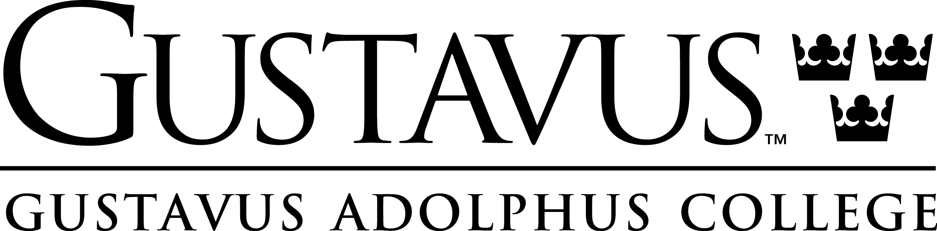
John S. Kendall Center for Engaged Learning

Faculty Development Day
Wednesday, August 27, 2008
Heritage Room

8:45 to 9:00 a.m. Social Time and Refreshments
Laura Behling, Director

9:00 to 10:30 a.m. Session I
Wabash

10:30 to 10:45 a.m. Break

10:45 to 12:15 p.m. Session II
Wabash

12:15 to 12:30 p.m. Break

12:30 p.m. Lunch and Evaluation

Best wishes for a sucessful semester

9:00 to 9:30 am Introduction and Social Time, Heritage Room
Julie Johnson, Advising ~ breakfast pastries and beverages
9:45 to 10:30 am Concurrent Session I
Session 1A: SOTL Heritage Room
Session 1B: SOTL St. Peter Room

10:45 to 11:30 am Concurrent Session II
Session 2A: Moodle Joyce Aarsvold, GTS St. Peter Room
Session 2B: Service Learning Elizabeth Baer, English Heritage Room

11:45 to 12:30 Concurrent Session III
Session 3A: Rubrics, Carolyn Dobler, Math & Computer Science Heritage Rm
Session 3B: Research Assignments Barbara Fister, Library St. Peter Room

12:30 to 1:00 pm Lunch
1:30 to 2:00 pm Overview of Faculty Development Opportunities and Grants

Best wishes for a sucessful semester

John S. Kendall Center for Engaged Learning
800 West College Avenue • St. Peter, MN 56082-1498 • http://gustavus.edu/kendallcenter/
Office Telephone: (507) 933-6227 • Fax: (507) 933-6338
This year, Faculty Development Day has a special focus that will allow us to learn more about our students, talk with each other about teaching and learning, and provide time for faculty to work together on course or assignment preparation. Our focus will be on using what we’ve learned about Gustavus first-year students from their participation in the Wabash Study of National Liberal Arts Education, and will offer faculty ways to address these study results in their courses. Do Gustavus students, for example, show an increase or decrease in their academic motivation and interest in academic subject matter or community involvement once they arrive? What teaching practices assist students in developing academic and intellectual success? What role do serious conversations with students who are very different in terms of their religious beliefs or political opinions play in Gustavus students’ educational lives?

We’ve invited Dr. Charles Blaitch and Kathy Wise, the director and associate director of the Wabash Center for Inquiry in the Liberal Arts, to pull out some striking data that can focus our attention on particular teaching/learning issues. And in the true spirit of a workshop, we’ll then talk with each other in small groups about what we’re learning, and consider ways our courses or assignments in our courses, may better address certain areas. For optimum productivity, please bring a syllabus for a course, or an assignment or sequence of assignments in a course, so that you can think how your own teaching practices address what you’re learning about our students.

Since Faculty Development Day also provides current faculty an opportunity to meet new faculty and share with them thoughts about who we are and what we are about as an academic community, we hope department chairs will encourage new faculty, and all faculty, to attend. As in previous years, we’ll also have a resource table with handouts of conferences, grants, and opportunities that may be of interest to you, and will provide breakfast refreshments and lunch for all participants.

Faculty Development Day begins at 9 a.m.; please plan to arrive between 8:45 and 9 a.m. to the Heritage Room, Campus Center for refreshments. This year’s workshop will end by 12:30 p.m., and all participants are invited to stay for lunch.

